<https://zoom.us/j/541492863>

**02/25/2019**



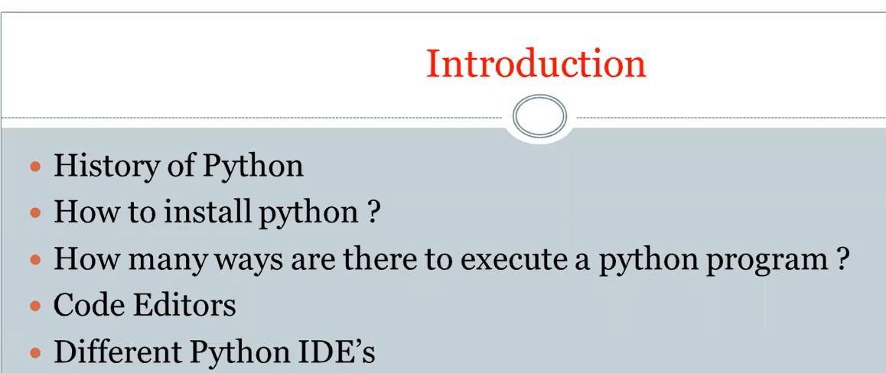

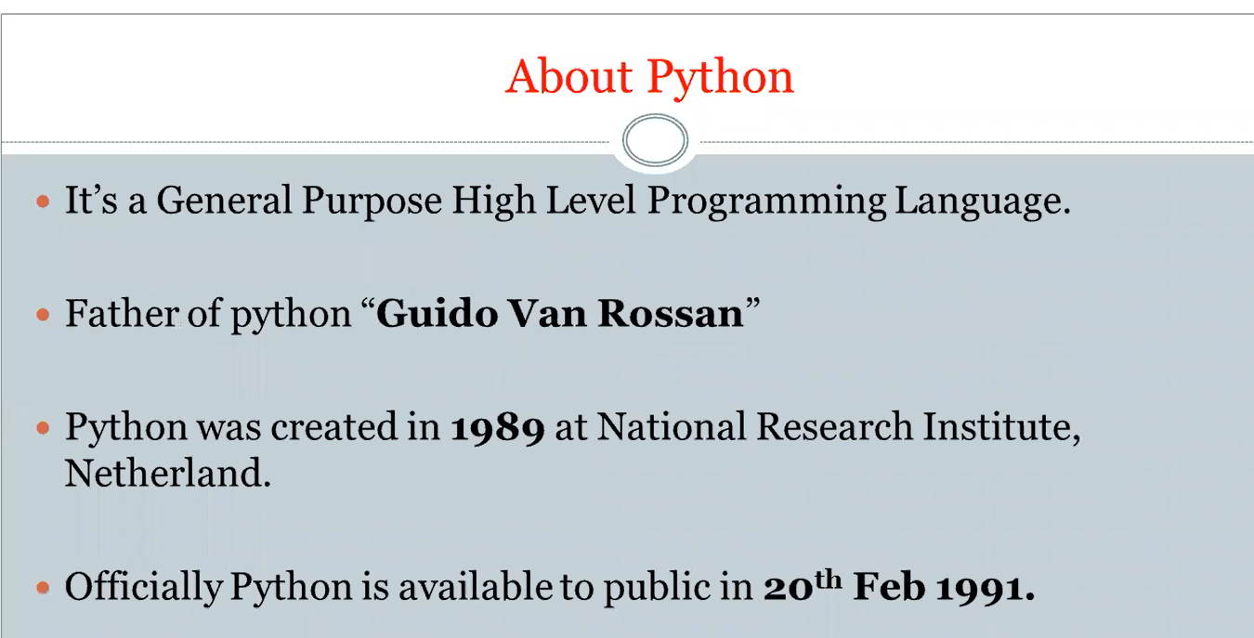

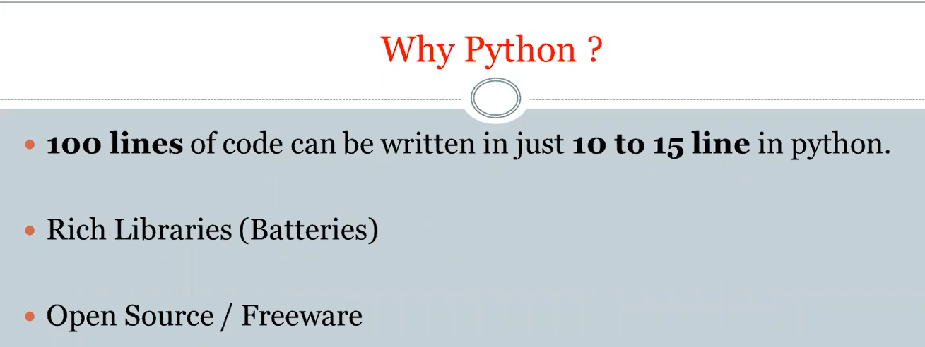

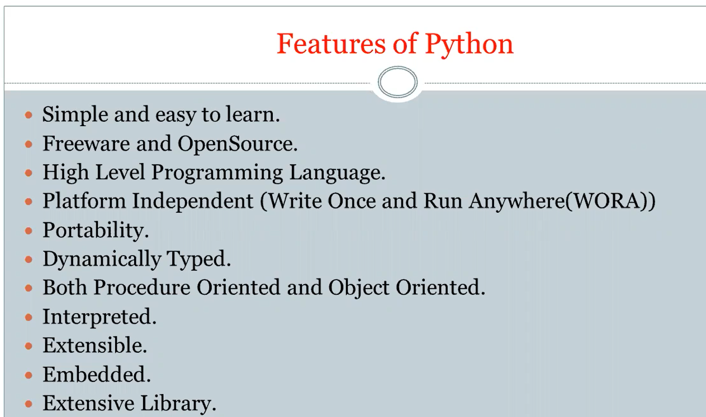

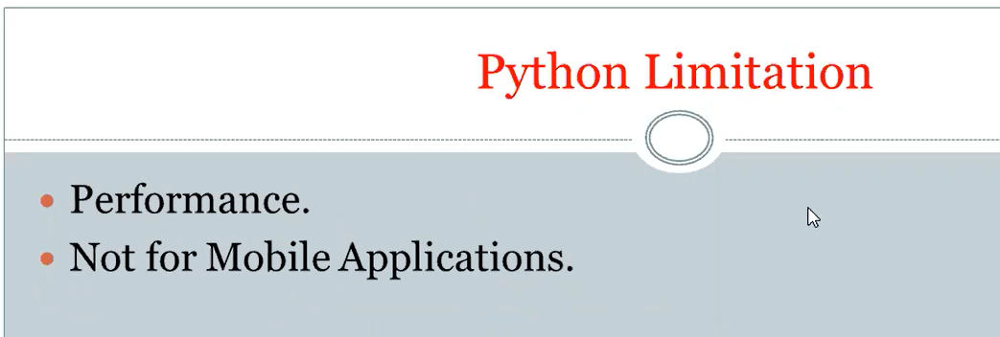

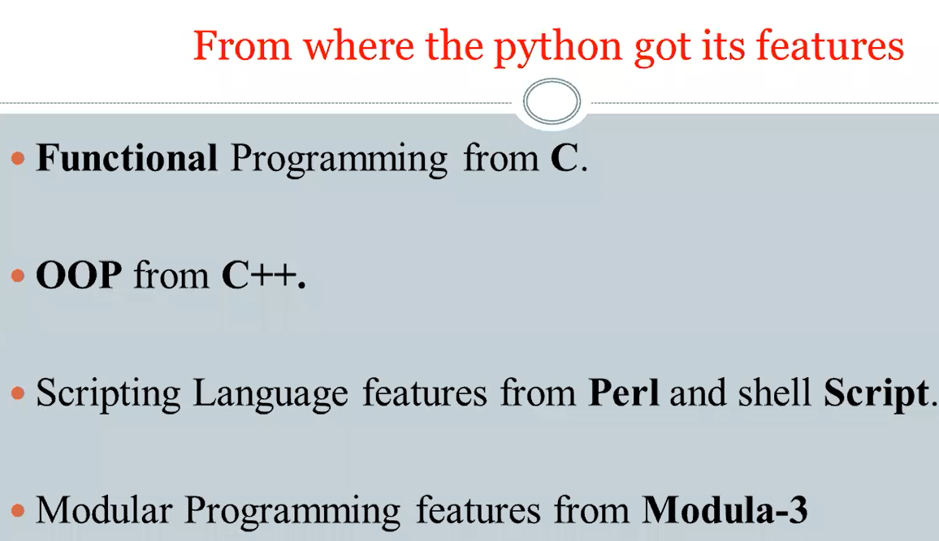

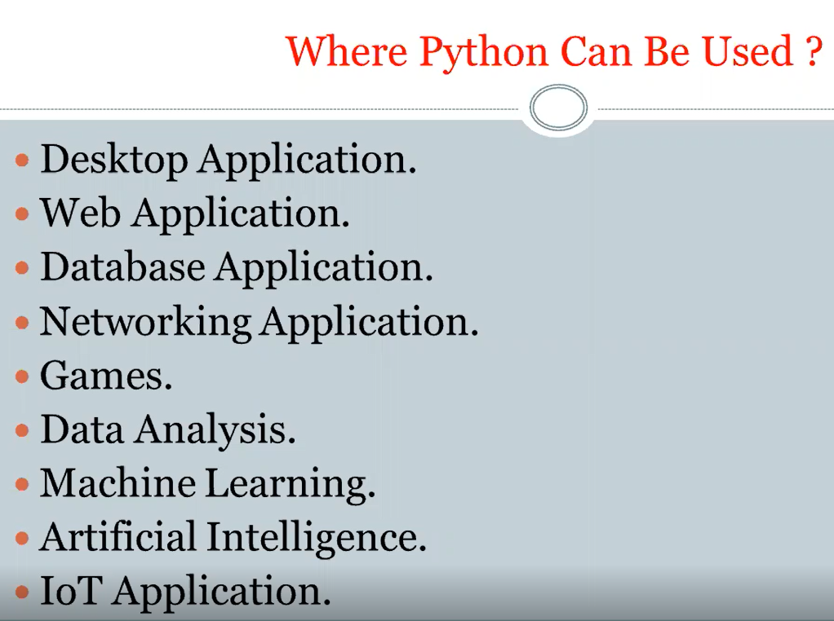



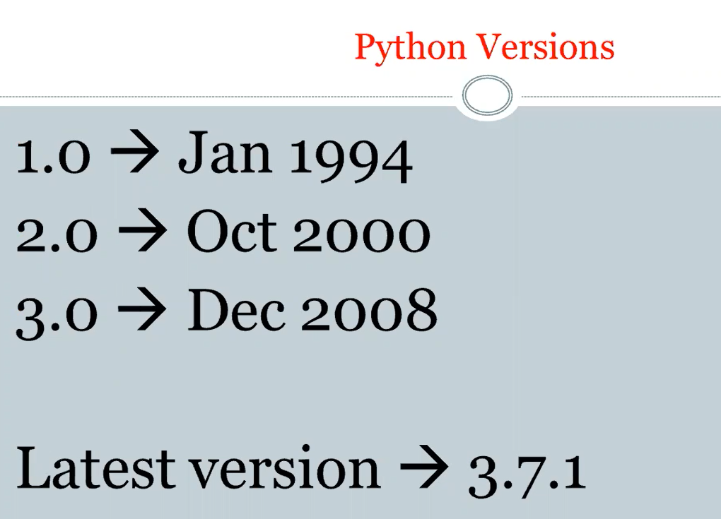

Now, actually it is 3.7.2

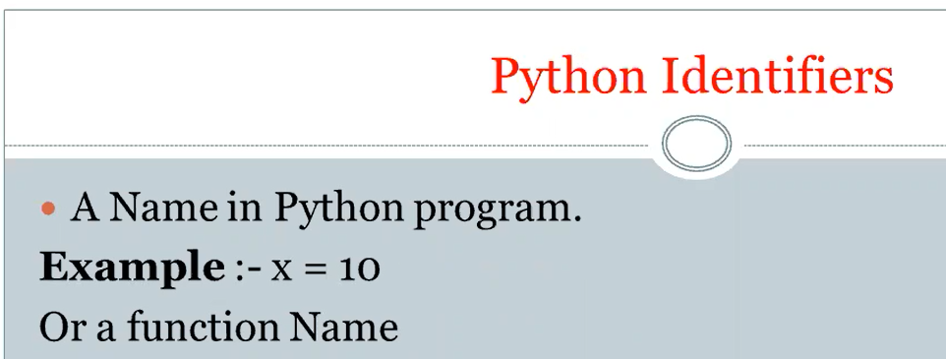

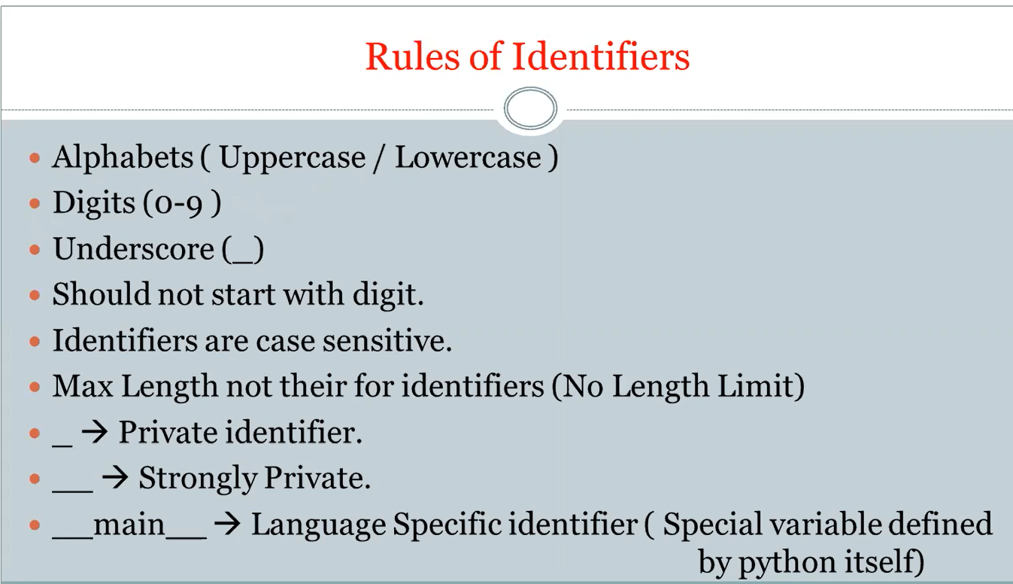

There arear 35 key words:

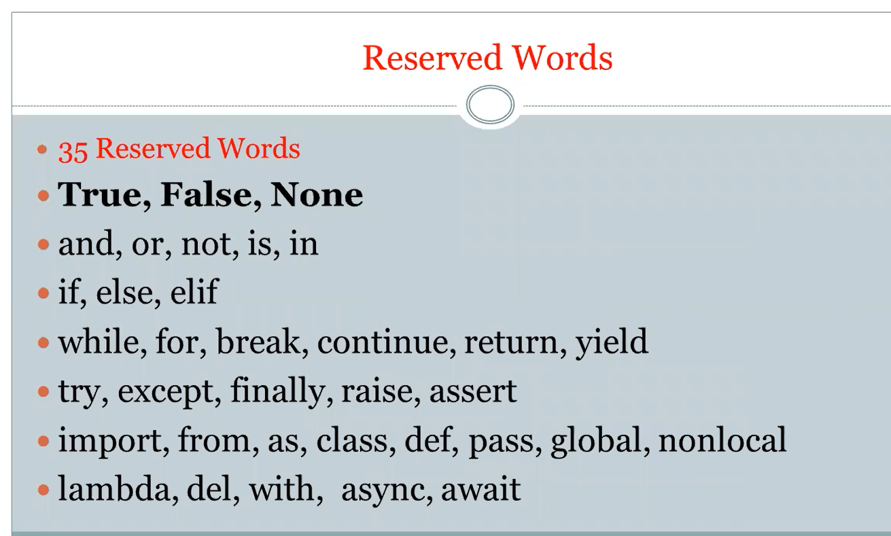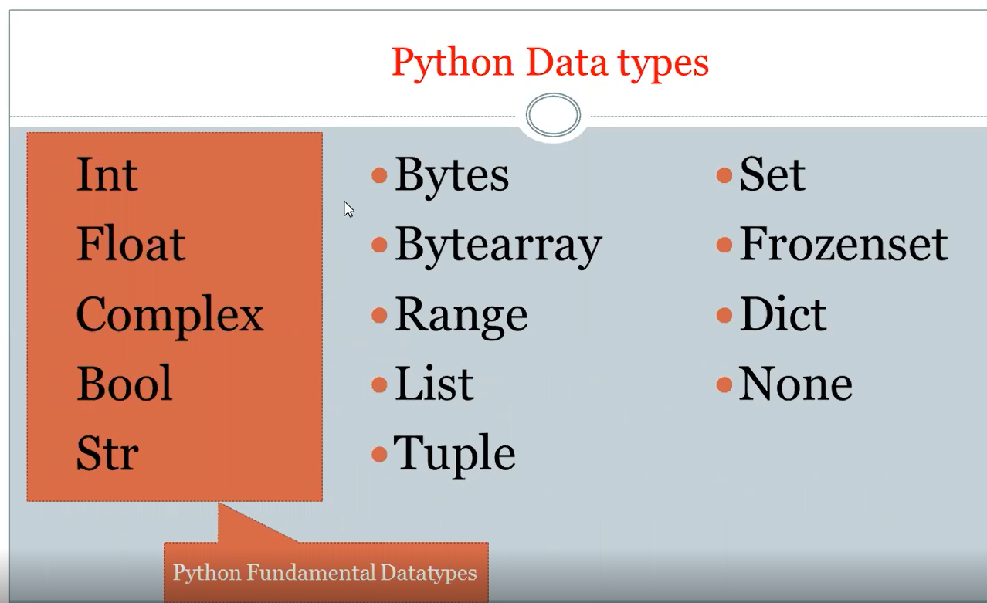

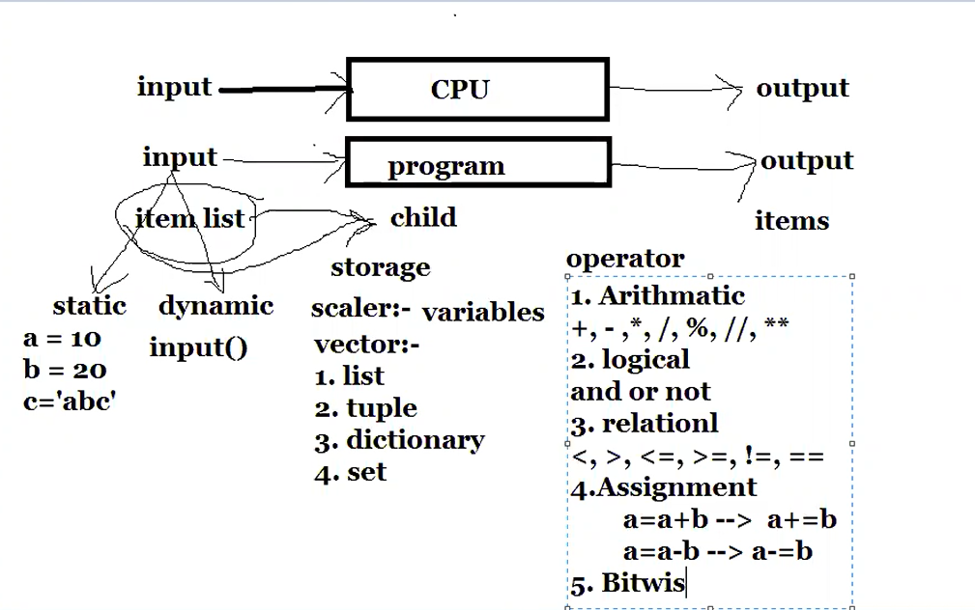

&, |

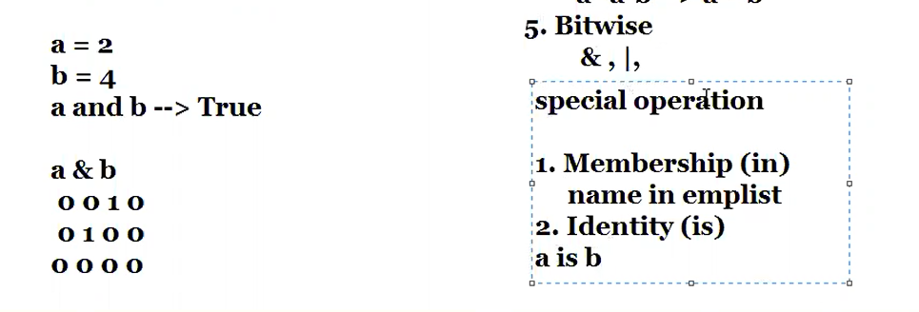

Let us see the identify operator in python:

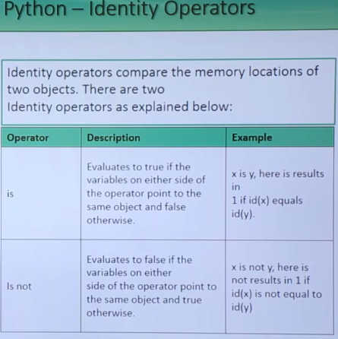

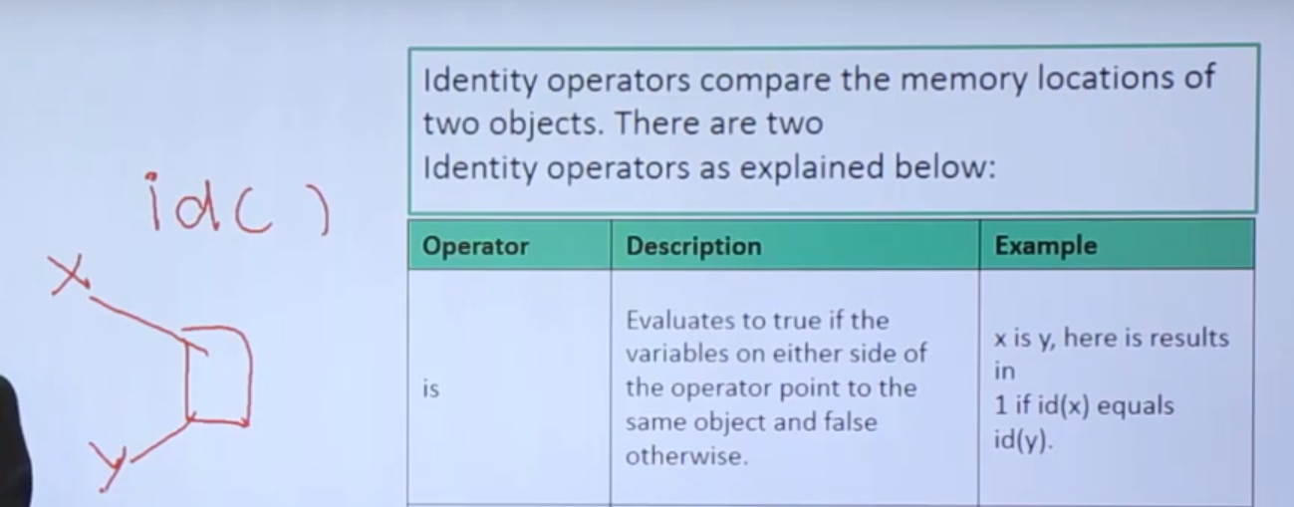

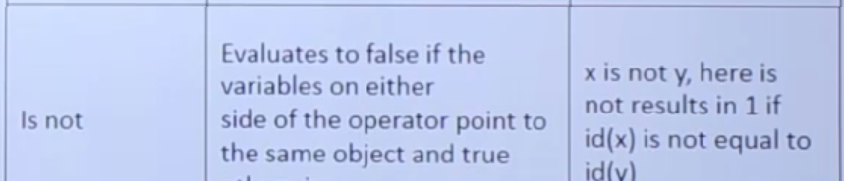  
id() is a built in function in python libs.

id() returns the uniform identification number provided by python’s interpreter to a particular object

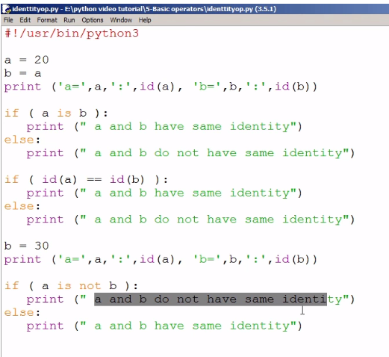

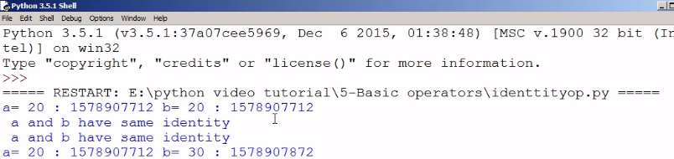

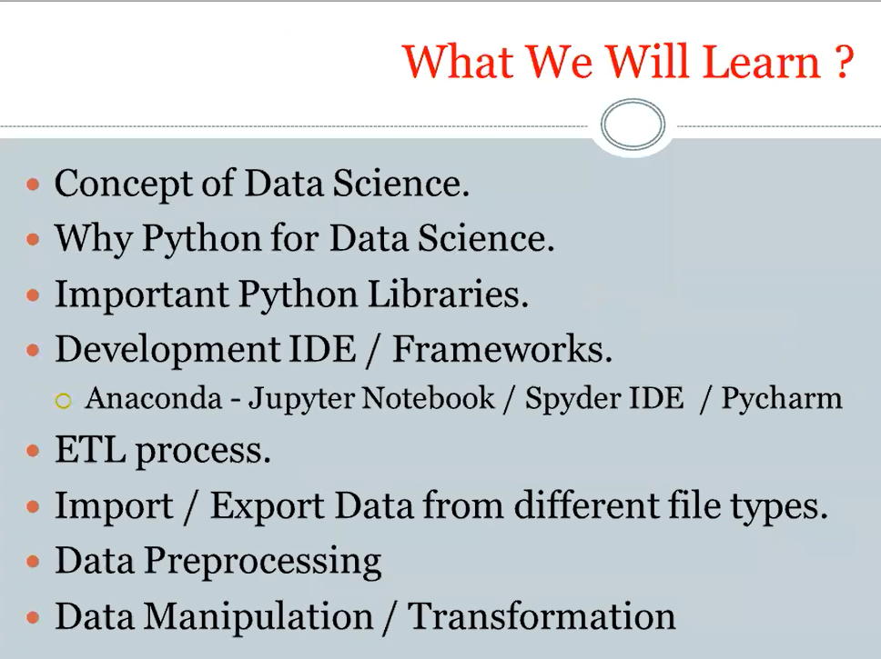

<http://www.u.arizona.edu/~erdmann/mse350/topics/list_comprehensions.html>

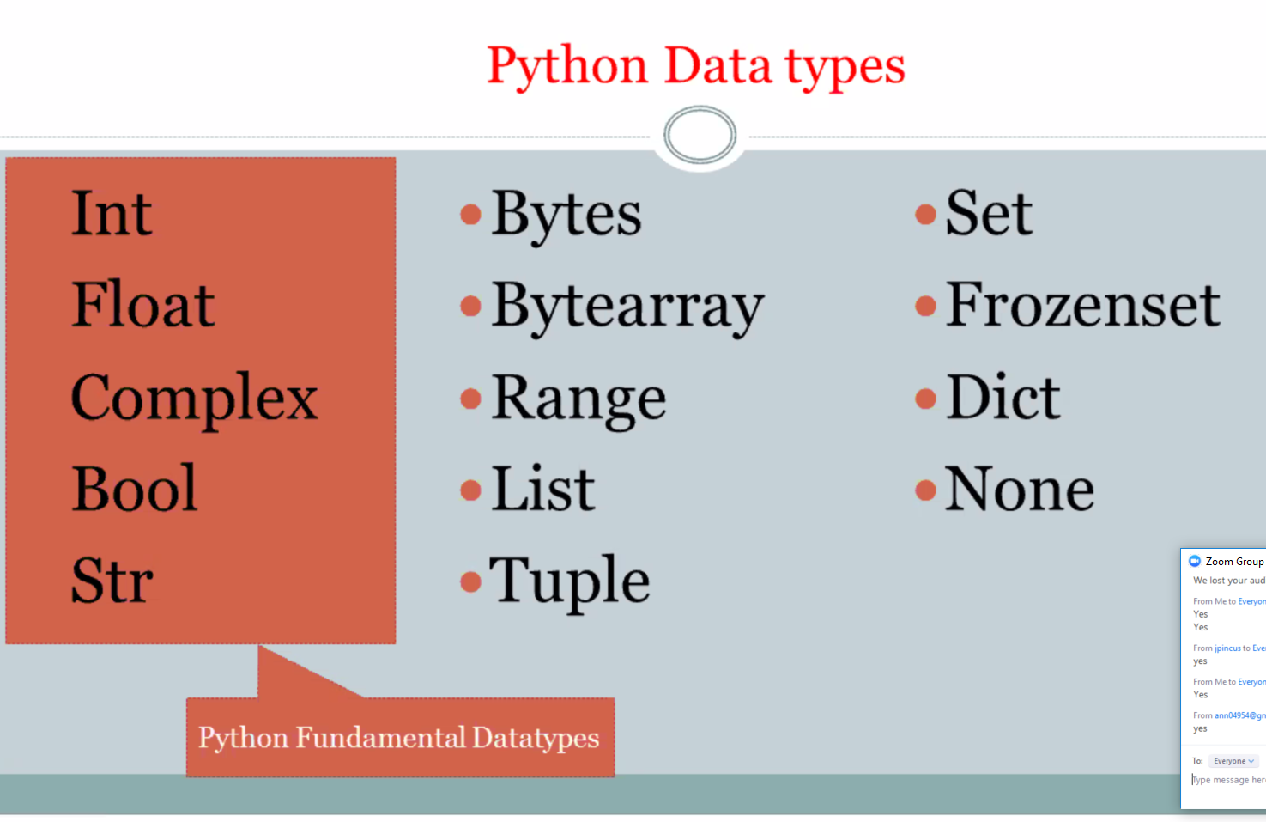

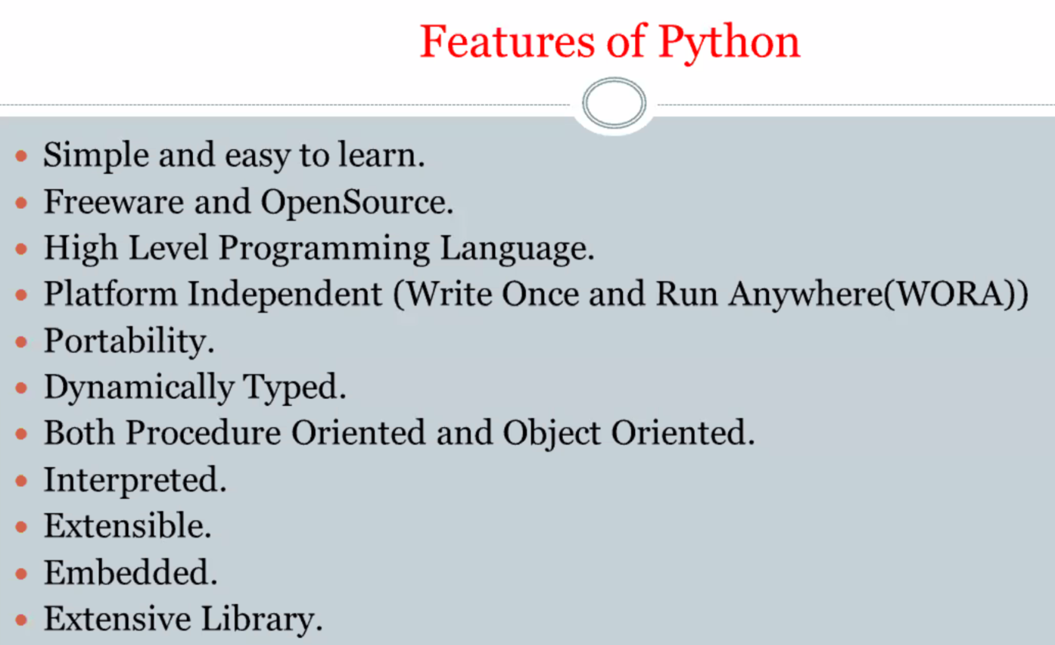

02/26/2019

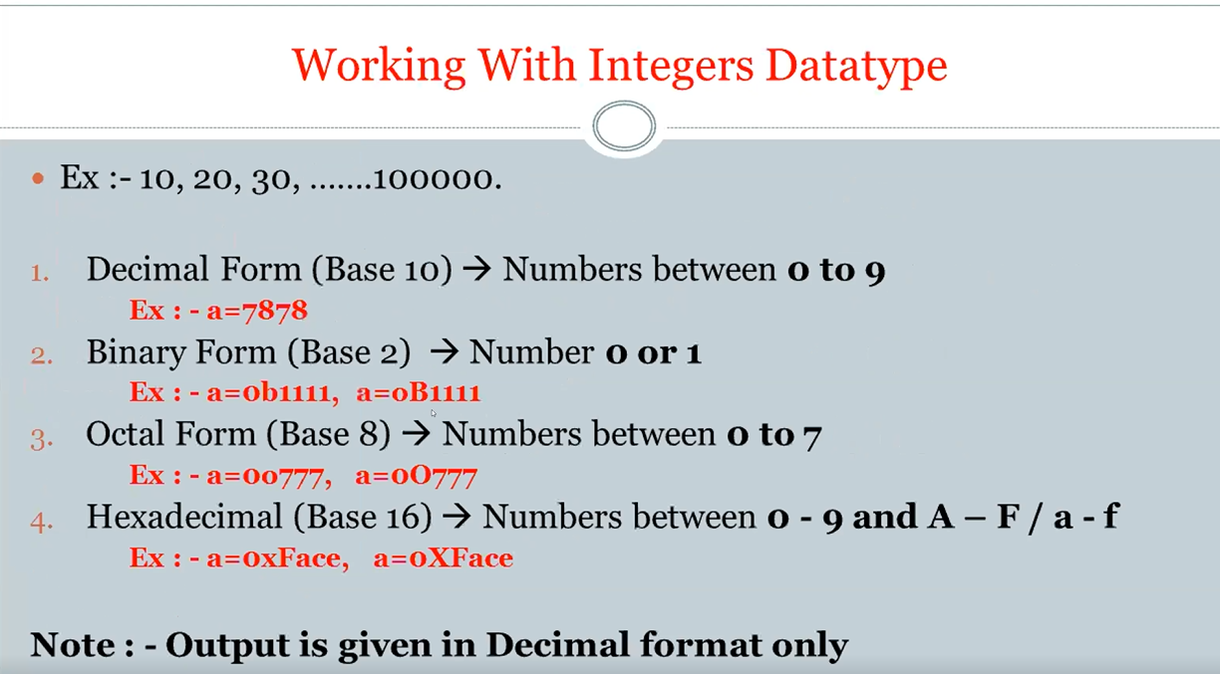

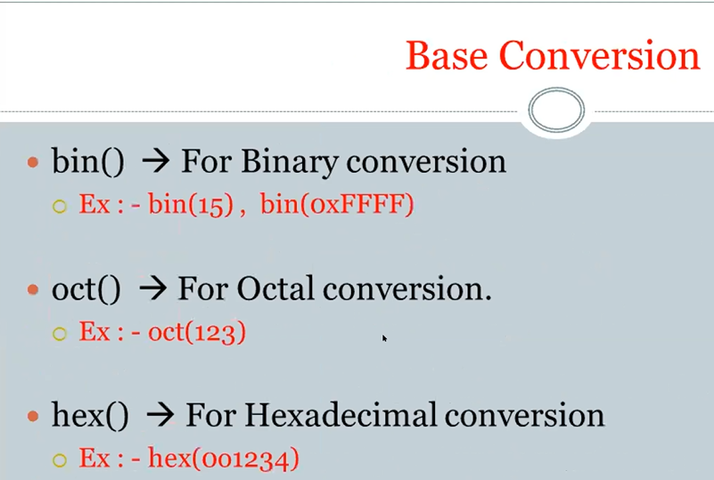

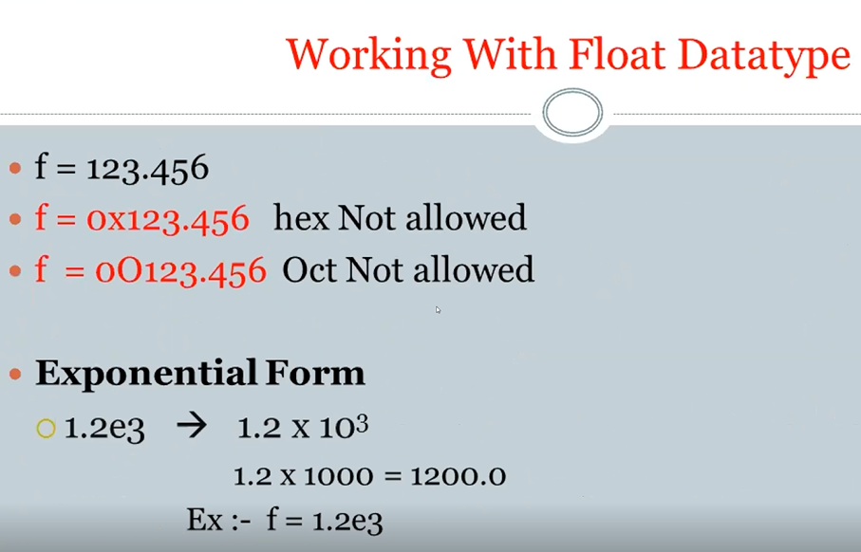

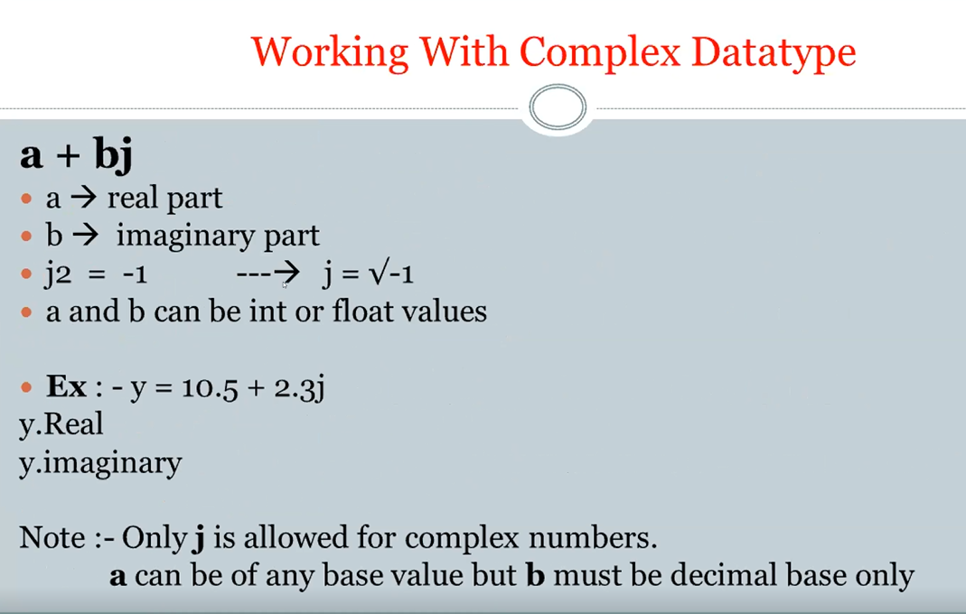

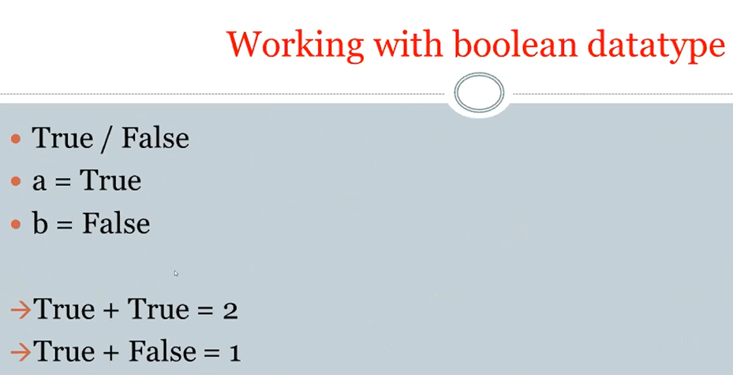

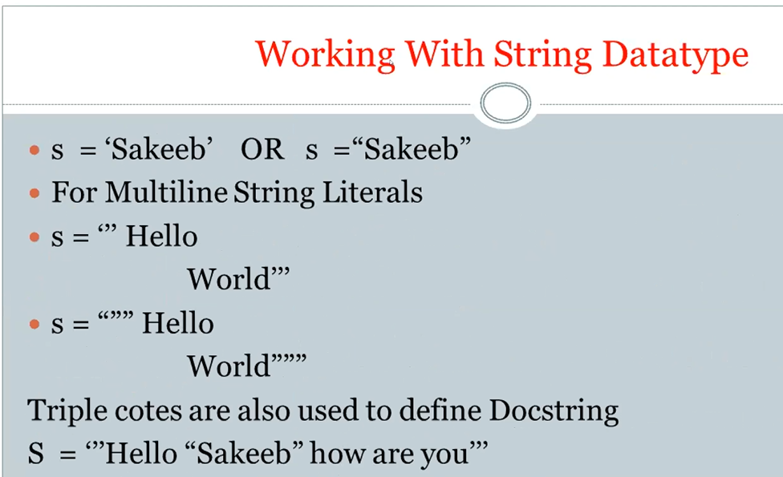

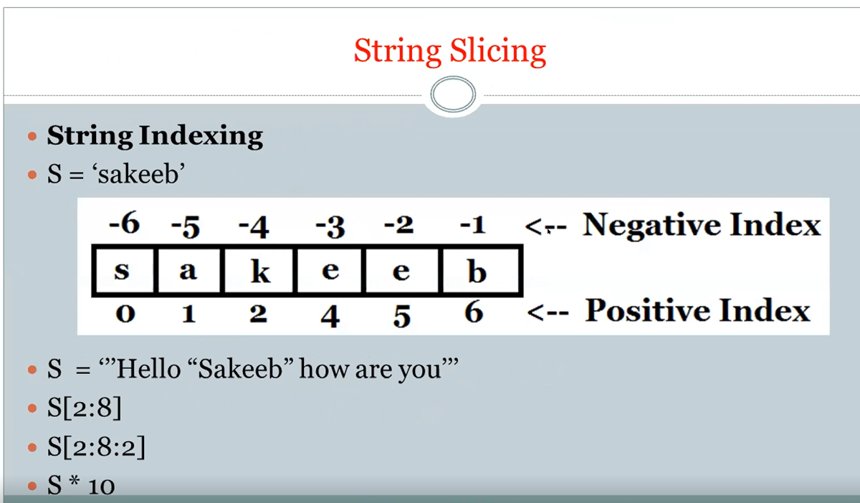

**2/27/2019**

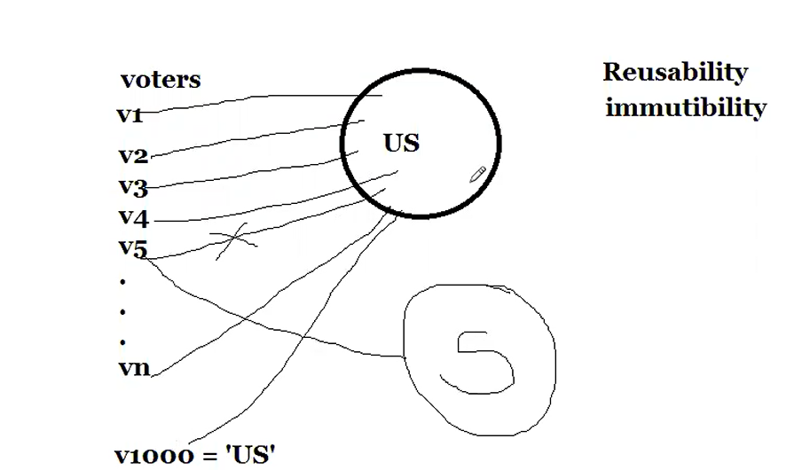

Immutibility is that an object is not allowed to be modified. The values are not changeable.

Why is the object is not allowed to be modified? Because the object is being referenced by many variables. There is only one object for all variables. So, we do not allow any of the variables like (v1, v2.. vn) to modify the object or value (or in this case US)

**All first 5 fundamental datatypes are immutable. That is any object created by using these 5 datatypes is not allowed to be modified because of reusability.**

Reusabilty

1. Int 🡺 0-256 (int is re-usable from 0 to 256

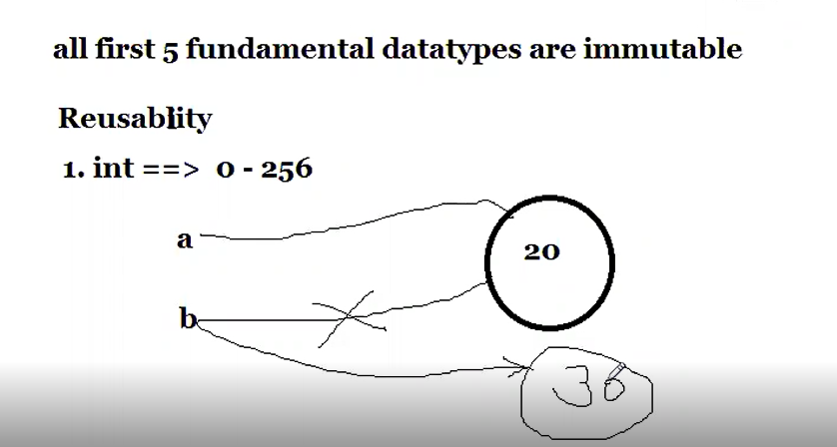

The int objects from 0-256 are created in advance so python does not need to research where to put 30. No need to create. They are already created in advance. Python just need to reference.

Only a reference to the object is passed.

Please note that there is no reusability is allowed for float and complex because they can not be defined in the range of numbers, so it is not feasible to reusablity for complex and float numbers. When you assign a variable of float and complex, a new object is created. So, float and complex are not allowed to be reused.

Bool – reusability always

Str - reusability always

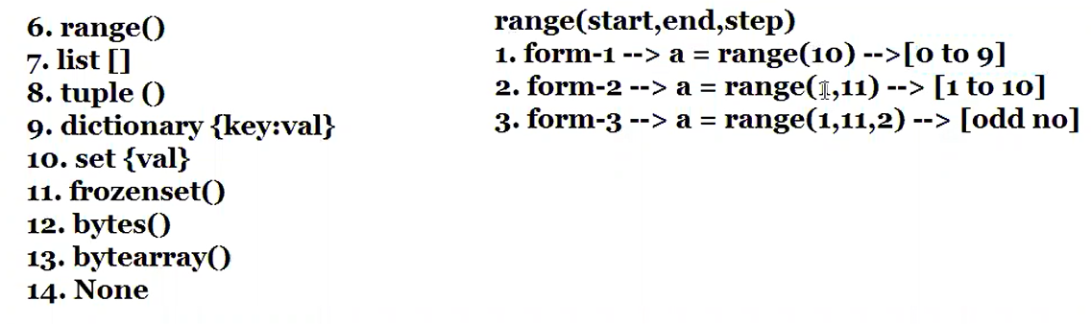

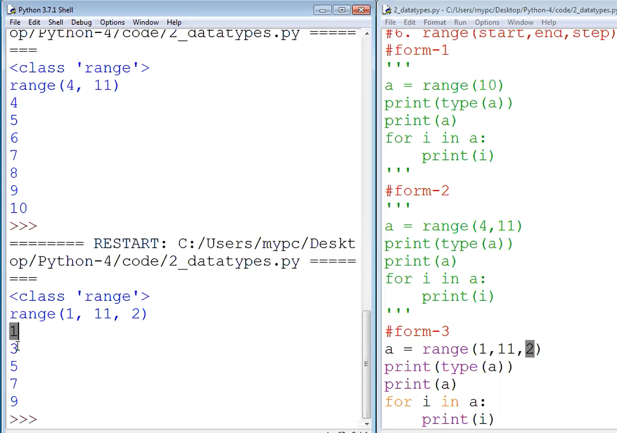

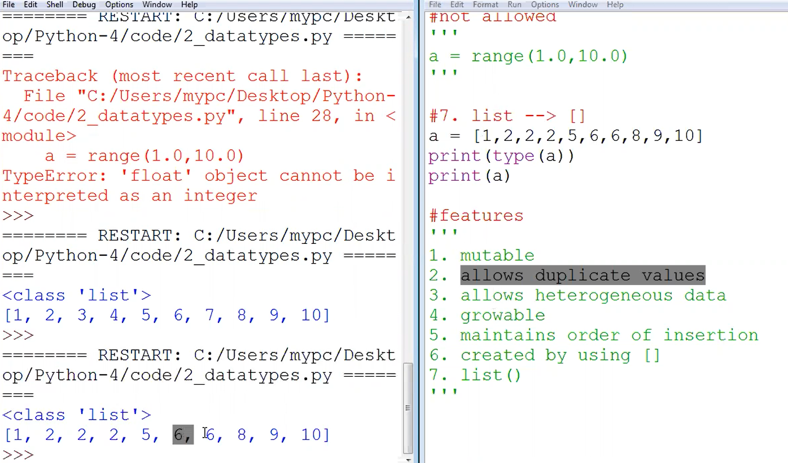

Hetergeneous data:

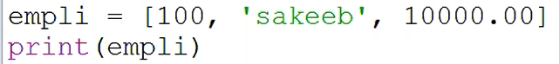

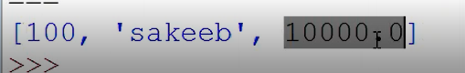

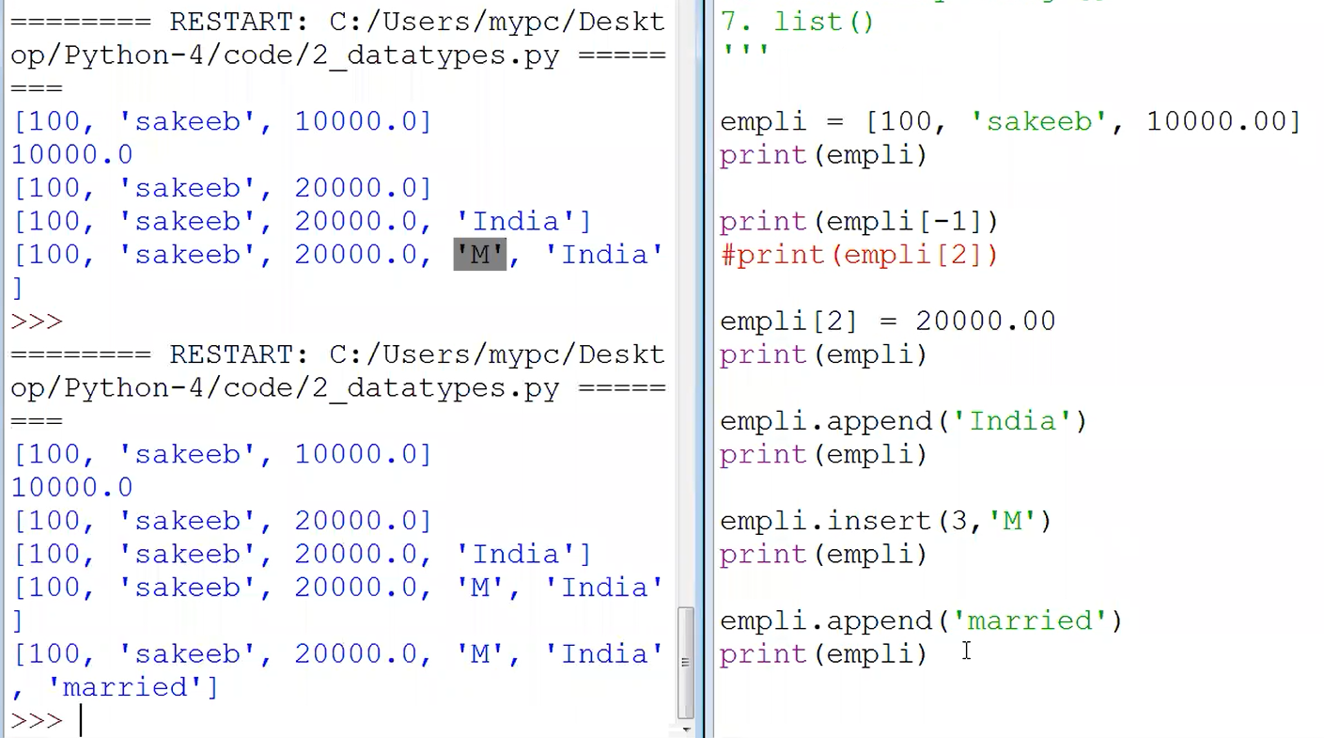

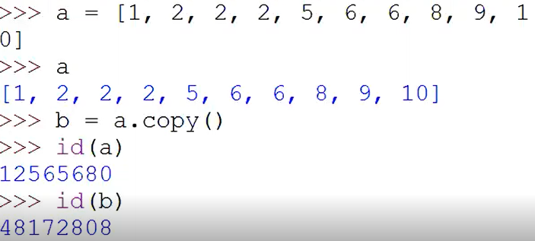

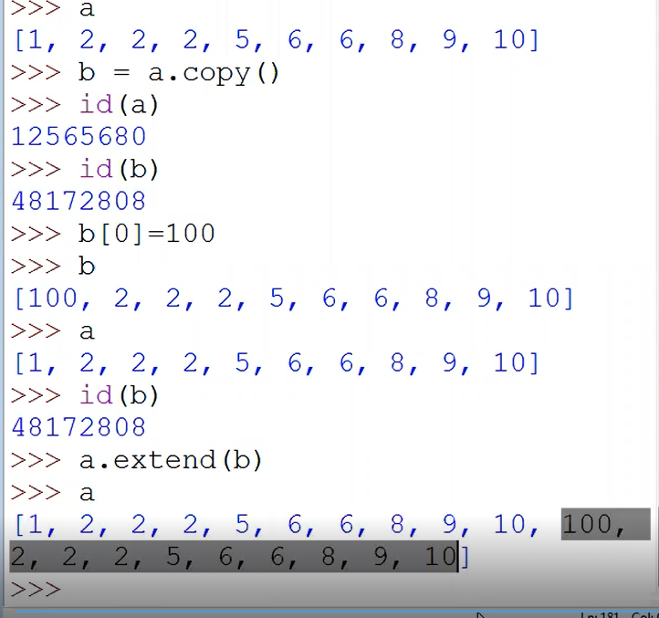

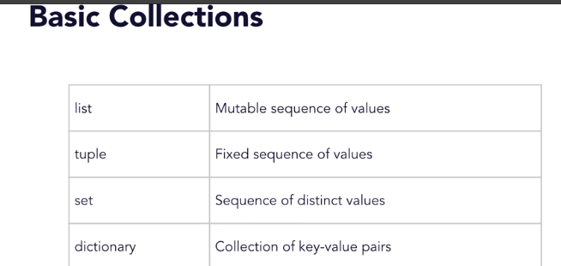

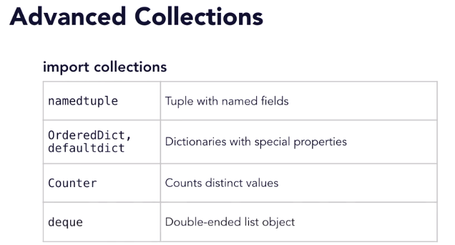

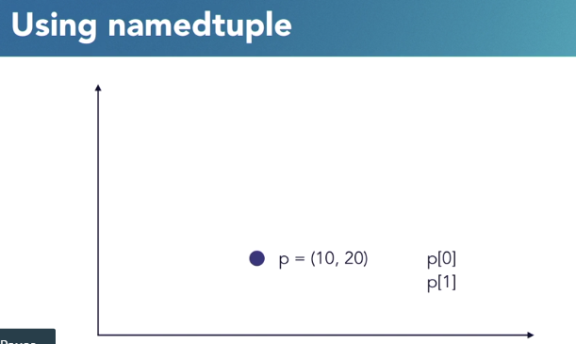

Dictionaries are:

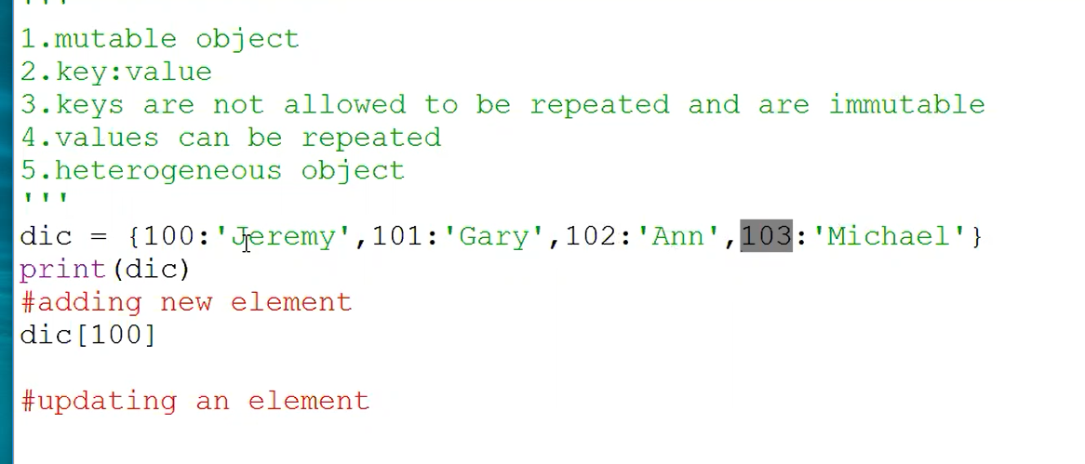

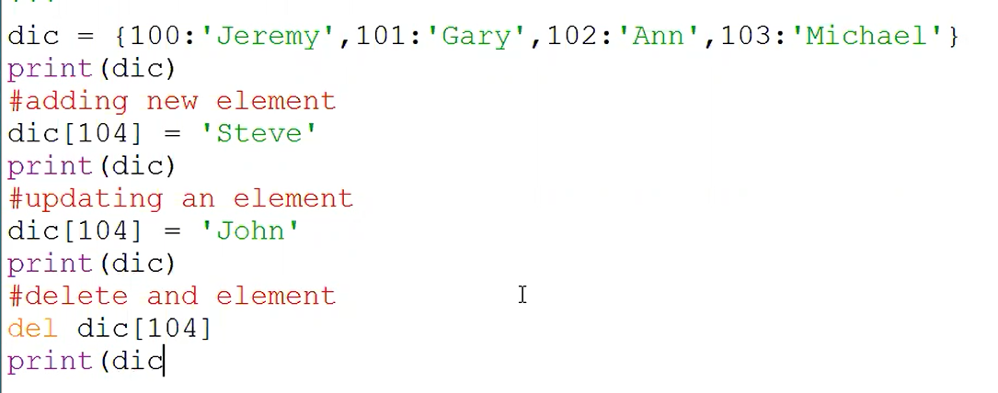

Dic.pop(103)

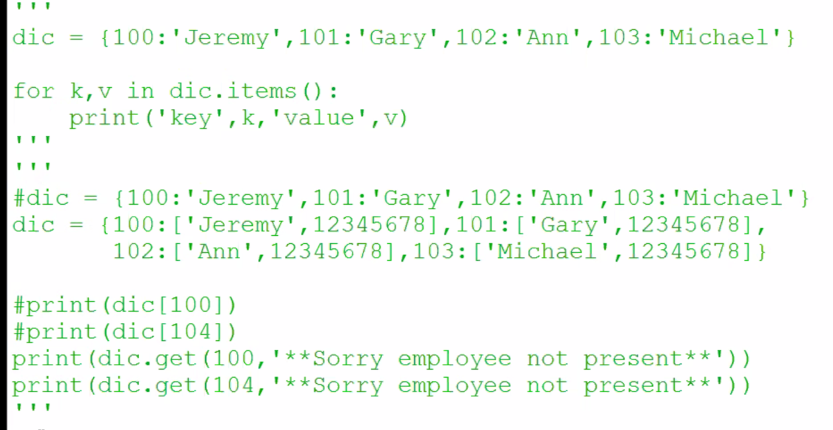

02/28/2019

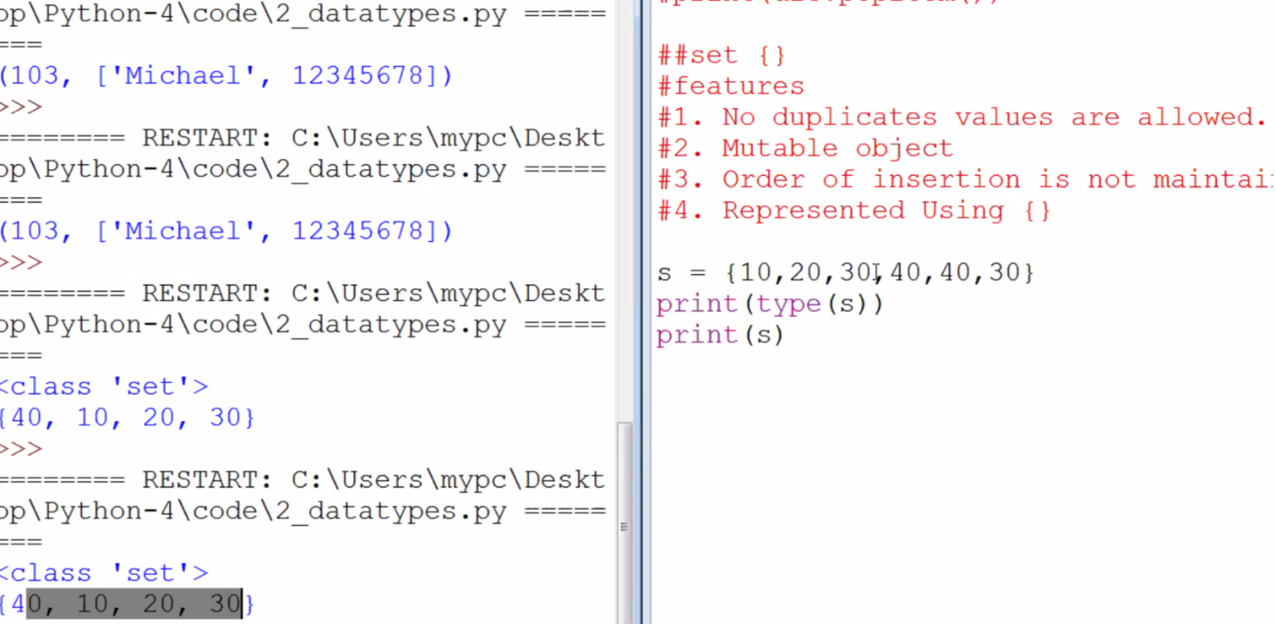

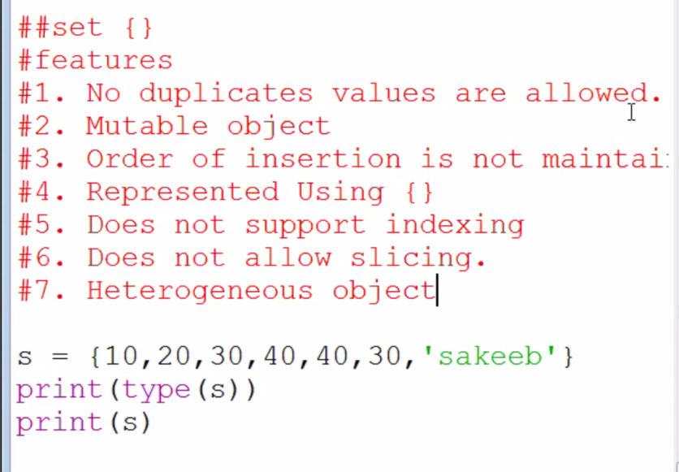

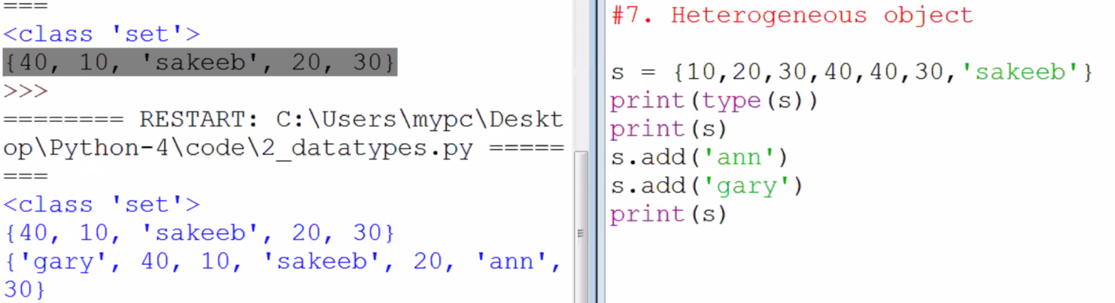

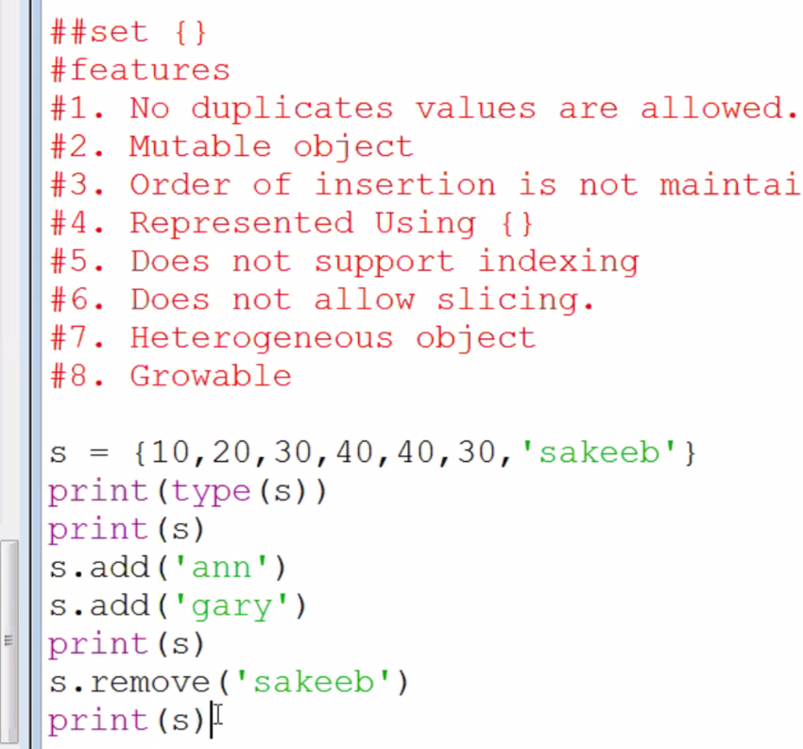

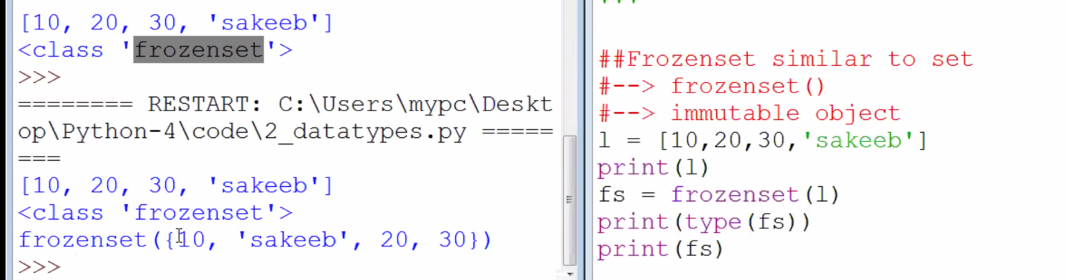

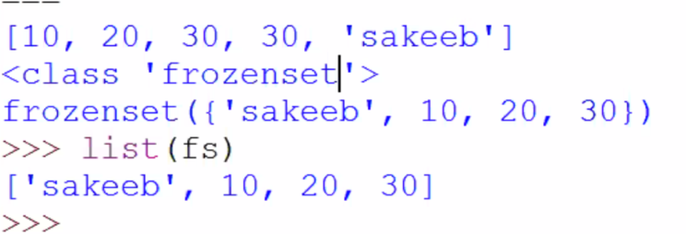

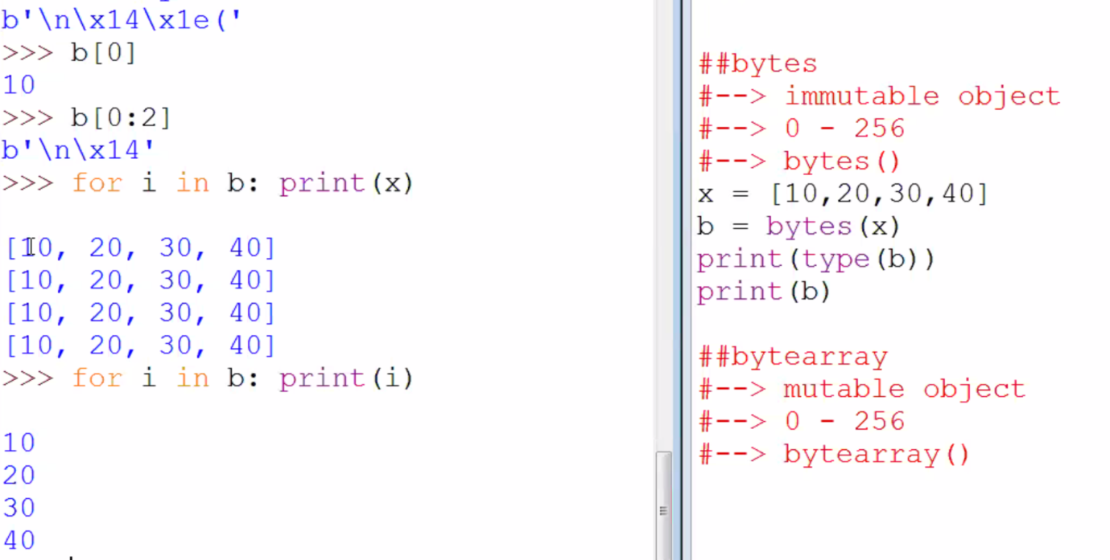

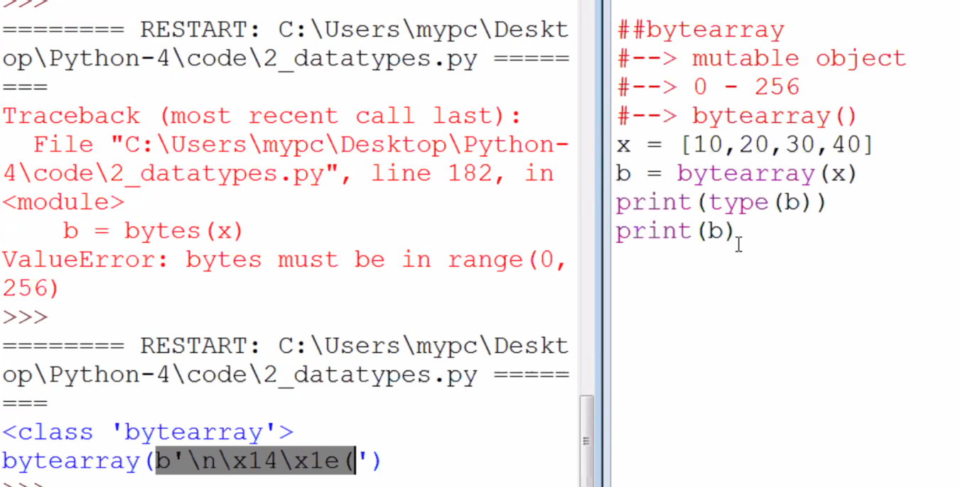

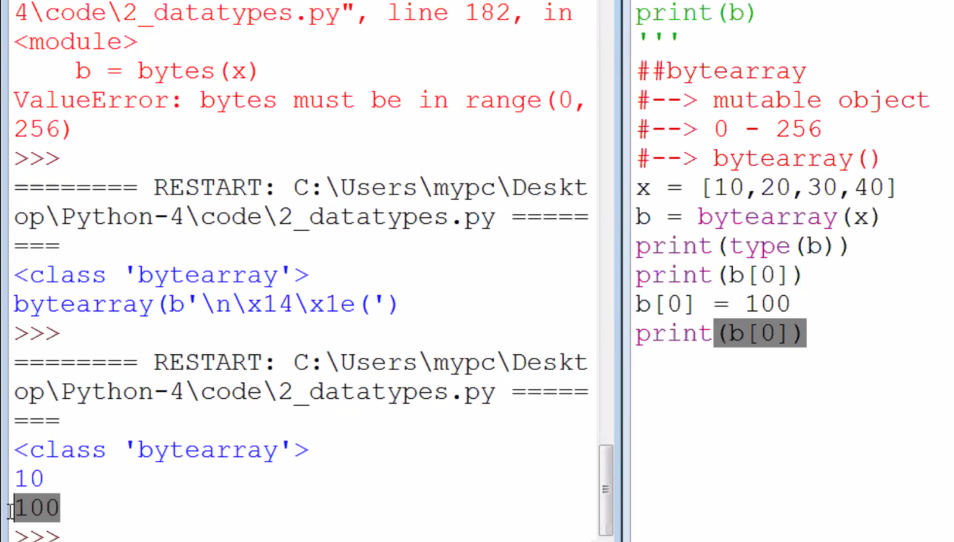

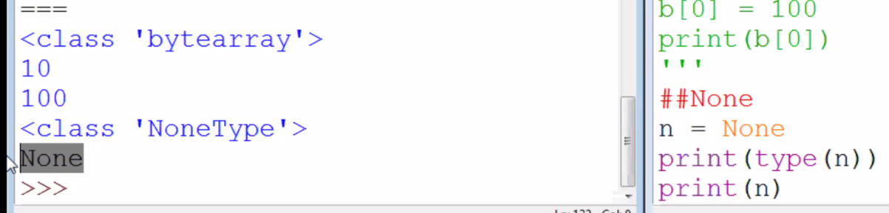

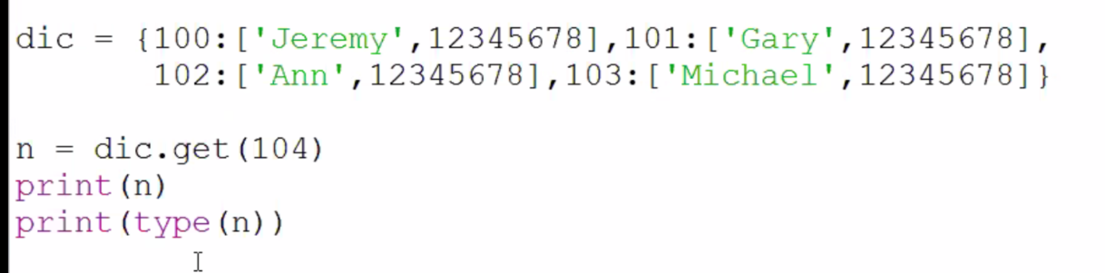

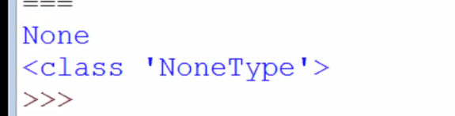

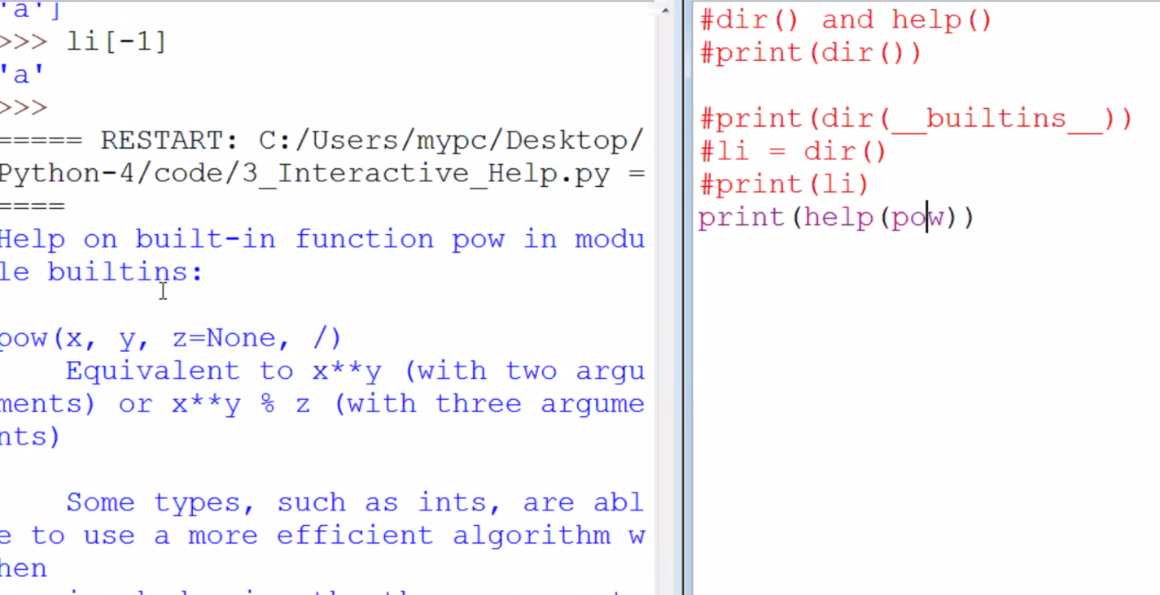

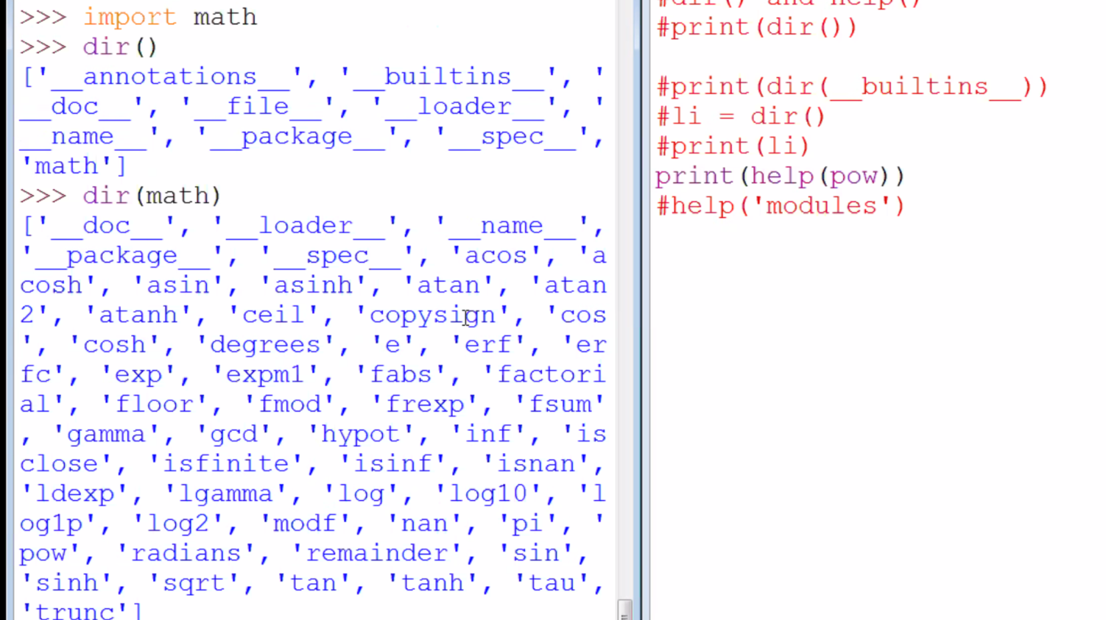

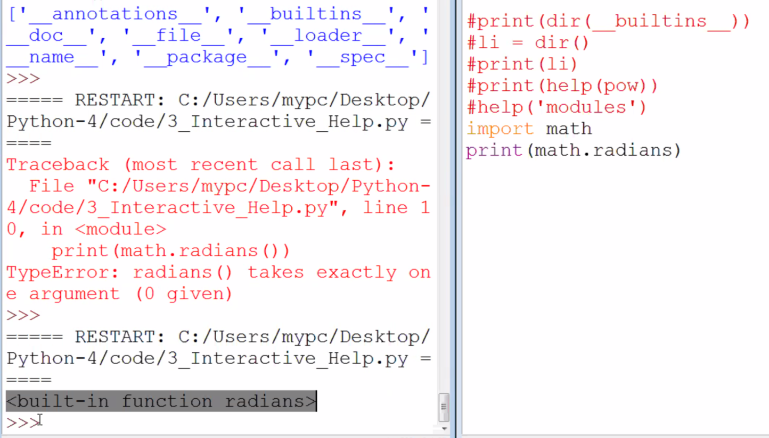

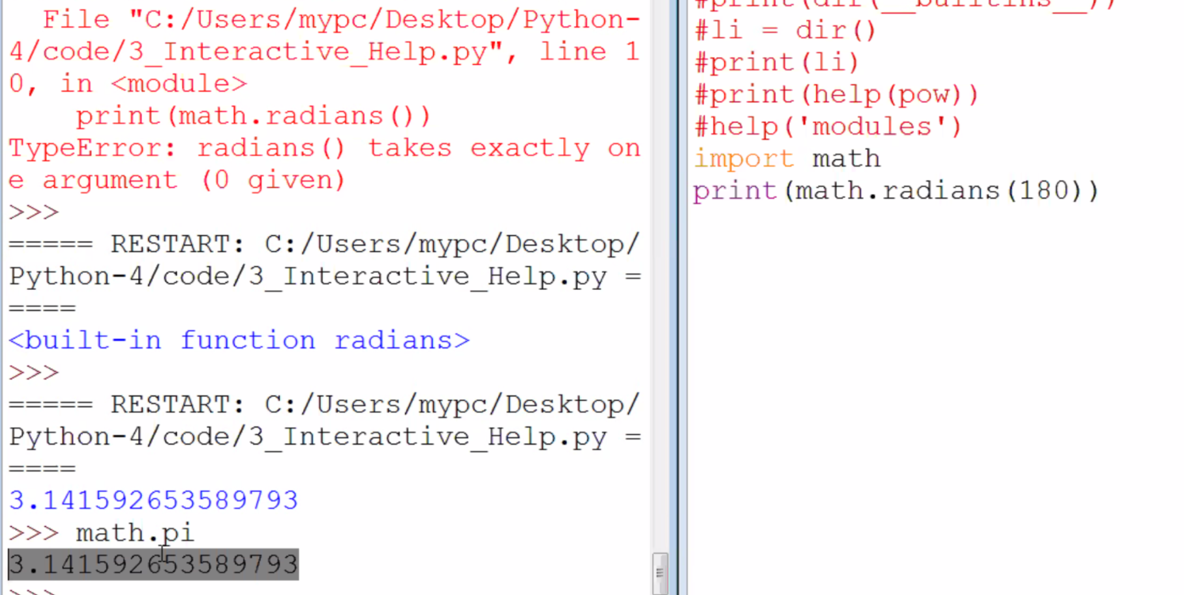

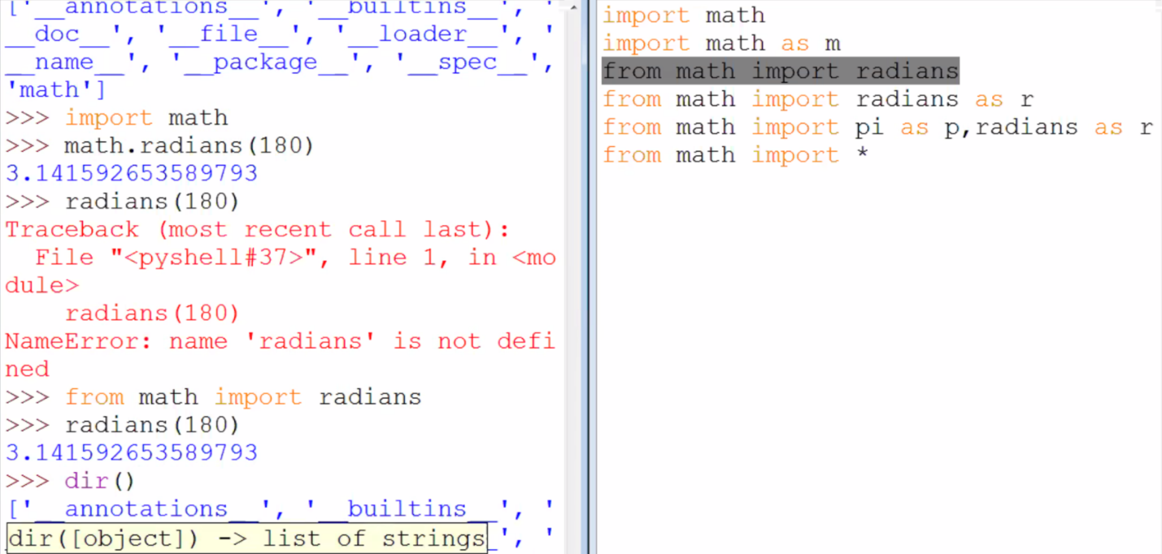

help('modules')

Please wait a moment while I gather a list of all available modules...

__future__ binascii getpass replace

__main__ binhex gettext reprlib

_abc bisect glob rlcompleter

_ast brain_argparse grep rpc

_asyncio brain_attrs gzip rstrip

_bisect brain_builtin_inference hashlib run

_blake2 brain_collections heapq runpy

_bootlocale brain_curses help runscript

_bz2 brain_dateutil help_about sched

_codecs brain_fstrings history scrolledlist

_codecs_cn brain_functools hmac search

_codecs_hk brain_gi html searchbase

_codecs_iso2022 brain_hashlib http searchengine

_codecs_jp brain_io hyperparser secrets

_codecs_kr brain_mechanize idle select

_codecs_tw brain_multiprocessing idle_test selectors

_collections brain_namedtuple_enum idlelib setuptools

_collections_abc brain_nose imaplib shelve

_compat_pickle brain_numpy imghdr shlex

_compression brain_pkg_resources imp shutil

_contextvars brain_pytest importlib signal

_csv brain_qt inspect site

_ctypes brain_random io six

_ctypes_test brain_re iomenu smtpd

_datetime brain_six ipaddress smtplib

_decimal brain_ssl isort sndhdr

_dummy_thread brain_subprocess itertools socket

_elementtree brain_threading json socketserver

_functools brain_typing keyword sqlite3

_hashlib brain_uuid lazy_object_proxy squeezer

_heapq browser lib2to3 sre_compile

_imp builtins linecache sre_constants

_io bz2 locale sre_parse

_json cProfile logging ssl

_locale calendar lzma stackviewer

_lsprof calltip macosx stat

_lzma calltip_w macpath statistics

_markupbase cgi mailbox statusbar

_md5 cgitb mailcap string

_msi chunk mainmenu stringprep

_multibytecodec cmath marshal struct

_multiprocessing cmd math subprocess

_opcode code mccabe sunau

_operator codecontext mimetypes symbol

_osx_support codecs mmap symtable

_overlapped codeop modulefinder sys

_pickle collections msilib sysconfig

_py_abc colorama msvcrt tabnanny

_pydecimal colorizer multicall tarfile

_pyio colorsys multiprocessing telnetlib

_queue compileall netrc tempfile

_random concurrent nntplib test

_sha1 config nt textview

_sha256 config_key ntpath textwrap

_sha3 configdialog nturl2path this

_sha512 configparser numbers threading

_signal contextlib opcode time

_sitebuiltins contextvars operator timeit

_socket copy optparse tkinter

_sqlite3 copyreg os token

_sre crypt outwin tokenize

_ssl csv paragraph tooltip

_stat ctypes parenmatch trace

_string curses parser traceback

_strptime dataclasses pathbrowser tracemalloc

_struct datetime pathlib tree

_symtable dbm pdb tty

_testbuffer debugger pep8 turtle

_testcapi debugger_r percolator turtledemo

_testconsole debugobj pickle types

_testimportmultiple debugobj_r pickletools typing

_testmultiphase decimal pip undo

_thread delegator pipes unicodedata

_threading_local difflib pkg_resources unittest

_tkinter dis pkgutil urllib

_tracemalloc distutils platform uu

_warnings doctest plistlib uuid

_weakref dummy_threading poplib venv

_weakrefset dynoption posixpath warnings

_winapi easy_install pprint wave

abc editor profile weakref

aifc email pstats webbrowser

antigravity encodings pty window

argparse ensurepip py_compile winreg

array enum pyclbr winsound

ast errno pycodestyle wrapt

astroid faulthandler pydoc wsgiref

asynchat filecmp pydoc_data xdrlib

asyncio fileinput pyexpat xml

asyncore filelist pylint xmlrpc

atexit fnmatch pyparse xxsubtype

audioop formatter pyshell zipapp

autocomplete fractions query zipfile

autocomplete_w ftplib queue zipimport

autoexpand functools quopri zlib

autopep8 gc random zoomheight

base64 genericpath re zzdummy

bdb getopt redirector

**03/01/2019**

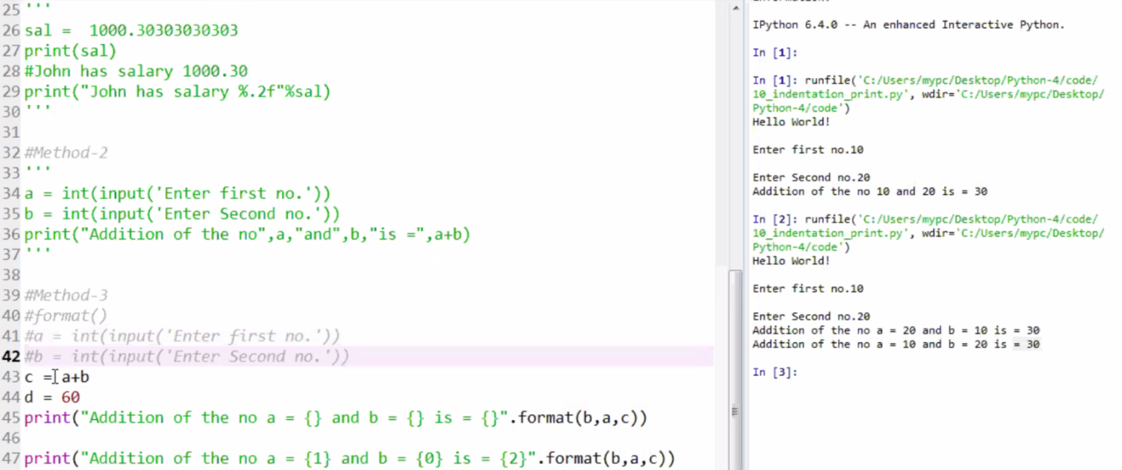

**1.**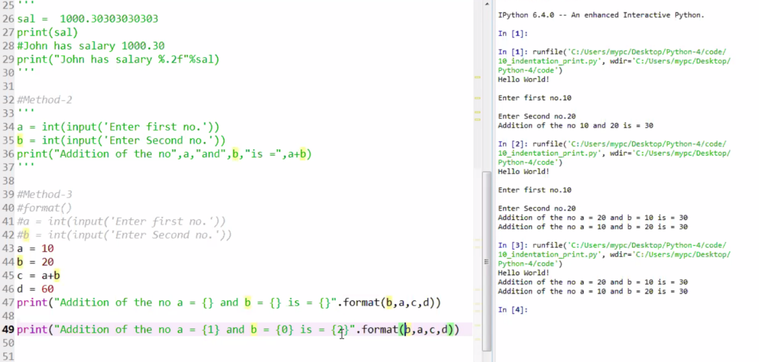

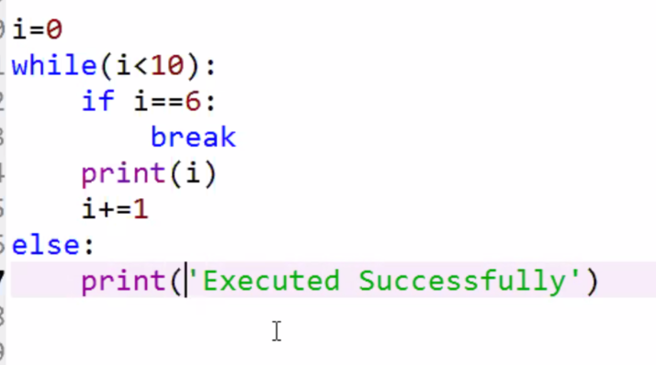

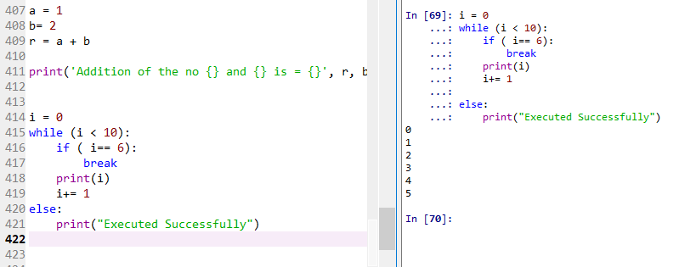

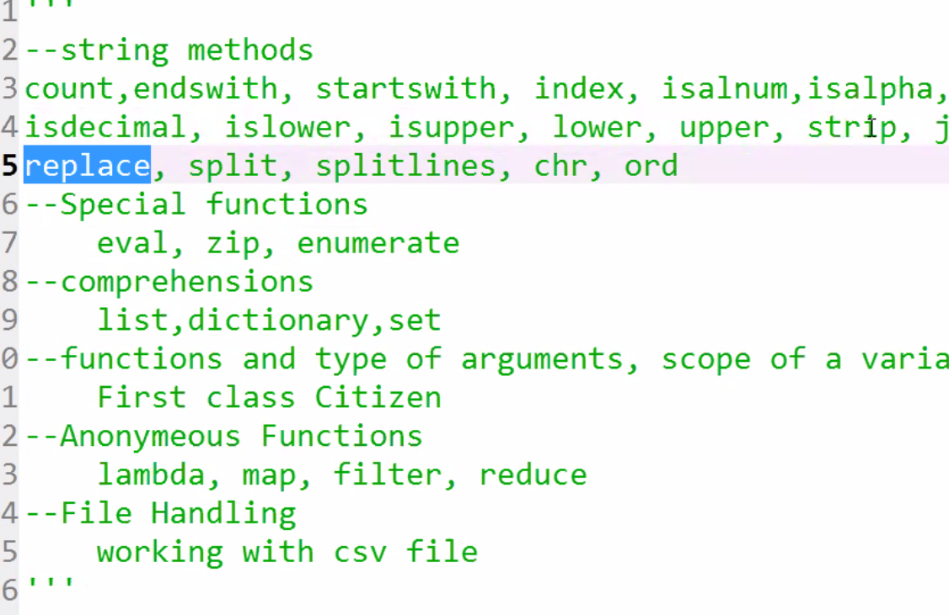

**03/05/2019**

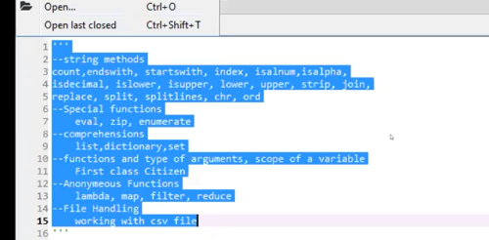

**Expect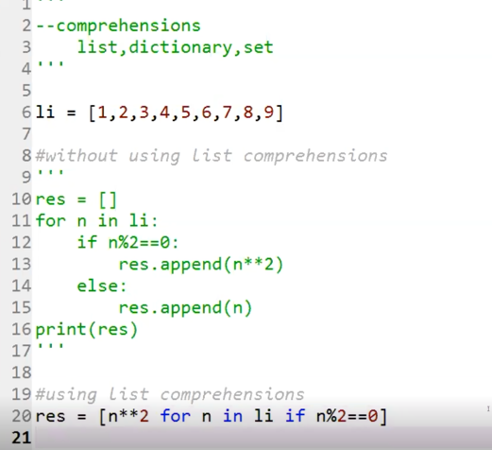ed result:** 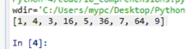

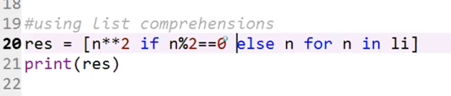

**Set with repeated values:**

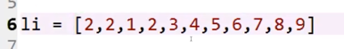

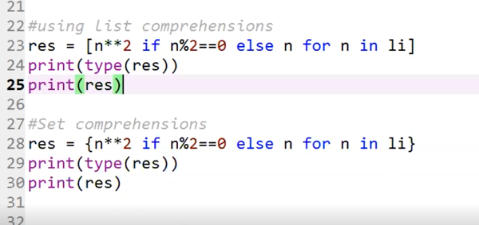 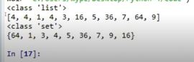

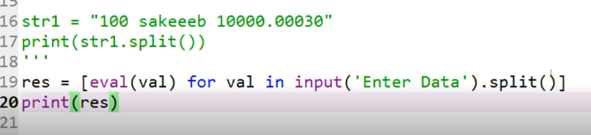

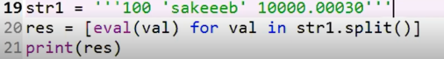

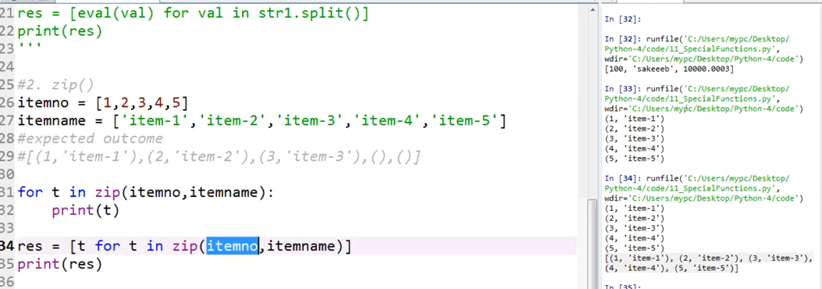

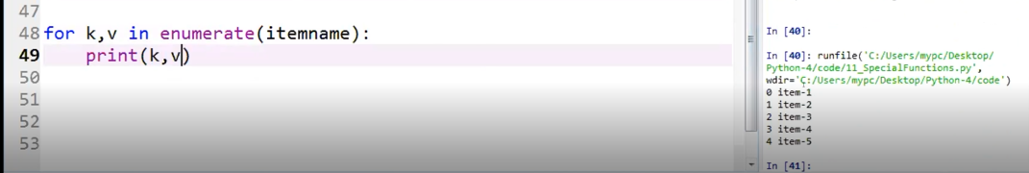

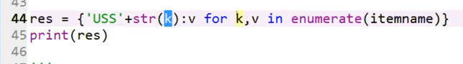

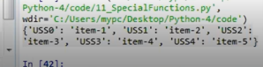

**Python Comprehensions**

**Observe this map from old training:**

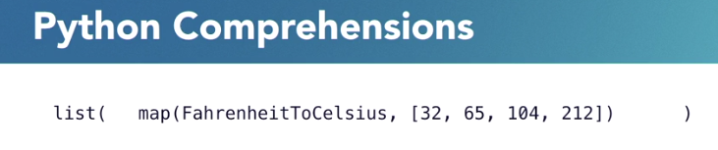

**The “FahrenheitToCelisus” method applies to the list which is the second argument**

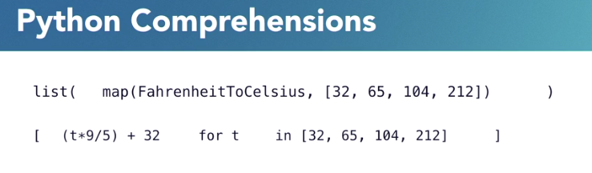

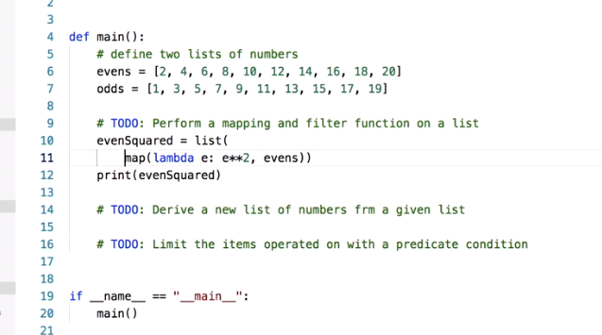

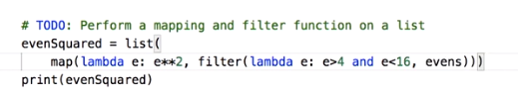

**Output:**

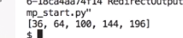

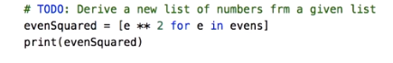

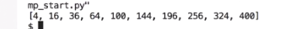

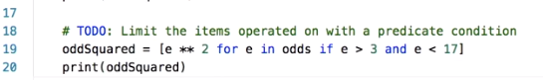

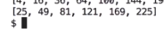

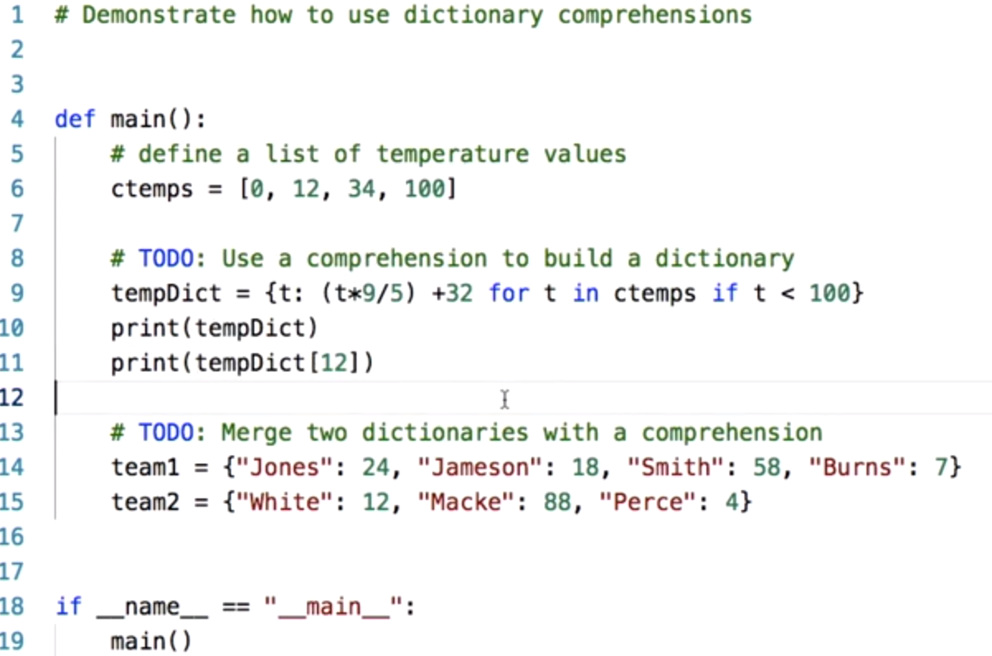

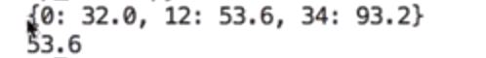

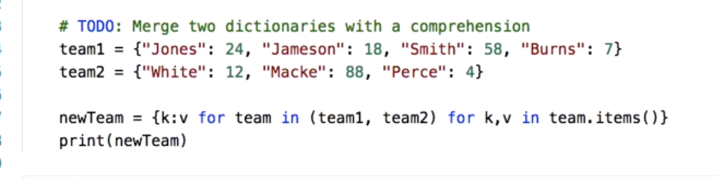



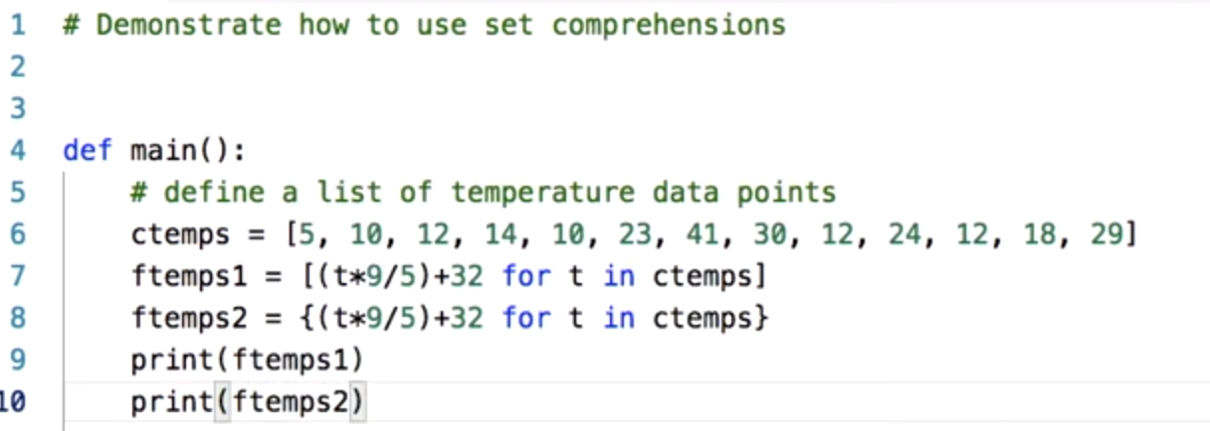



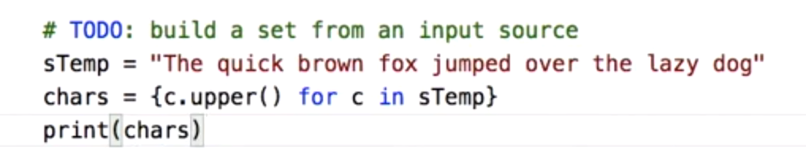



**Remove white space: by adding if not c.isspace()**

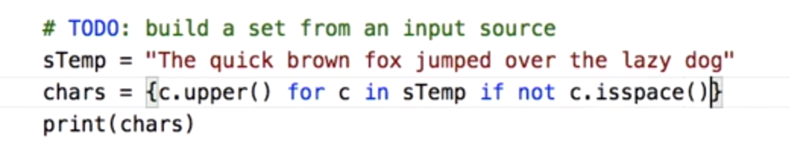

**See no space after I**



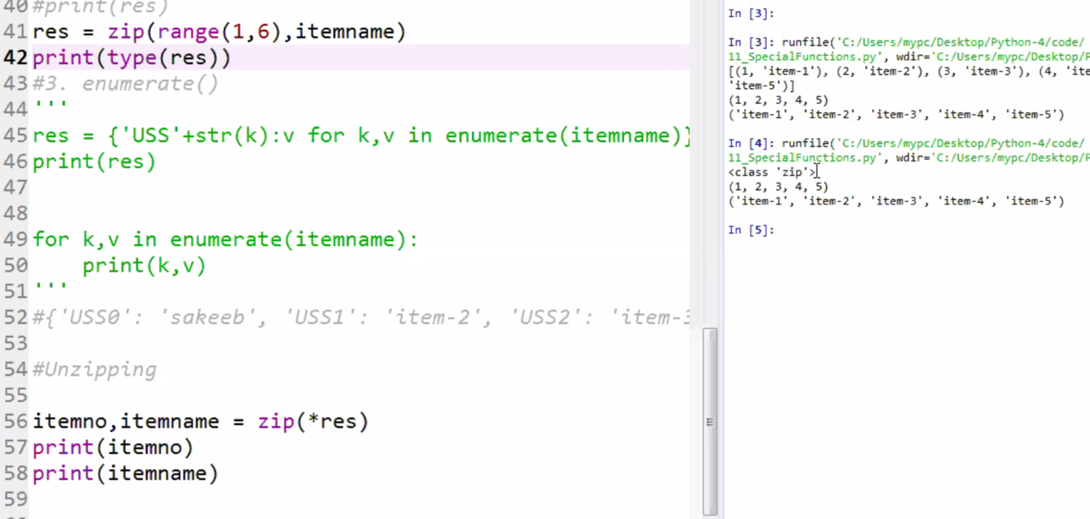

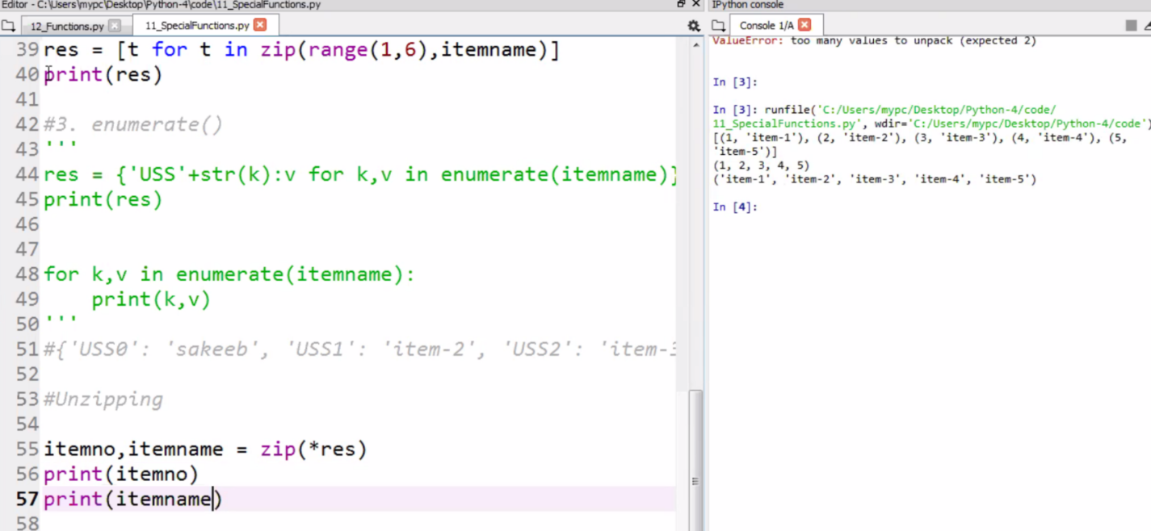

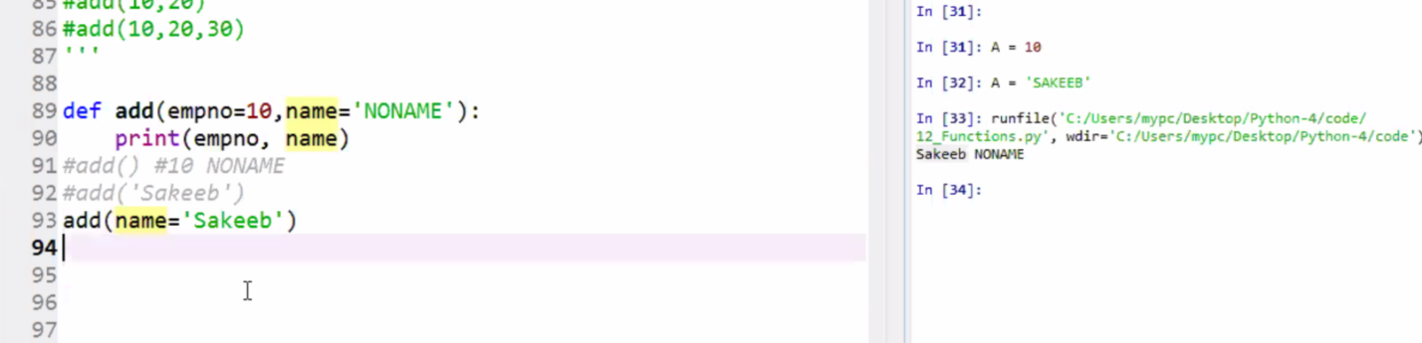

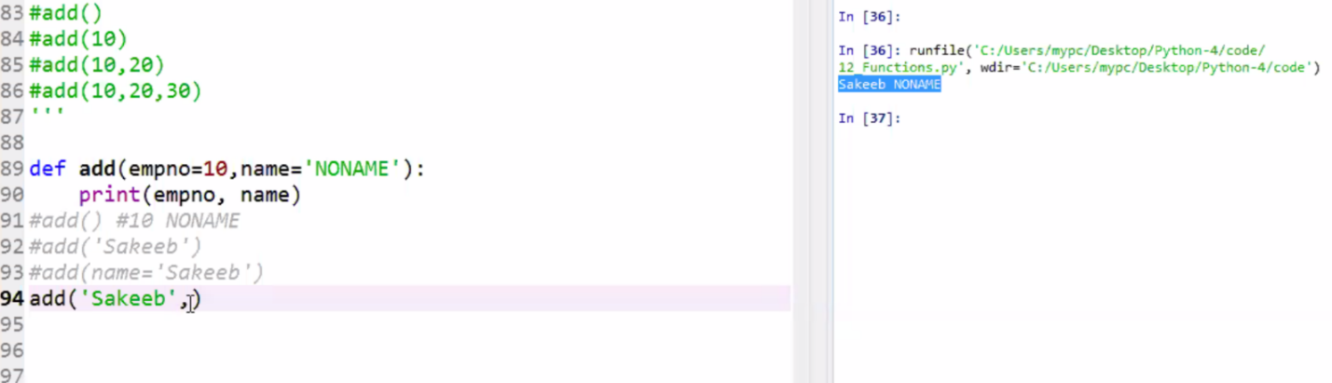

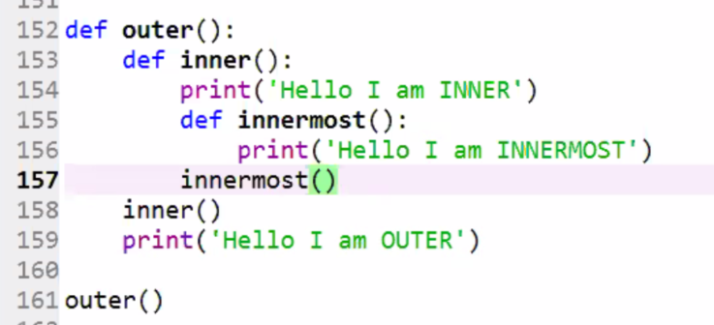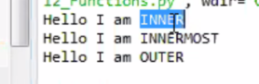

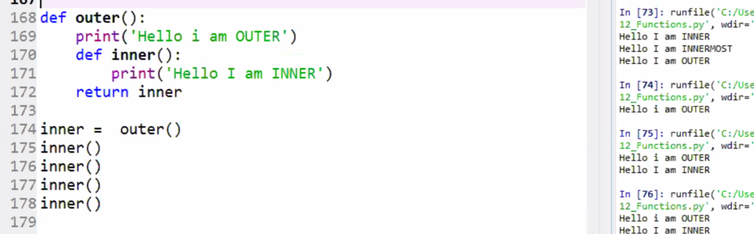

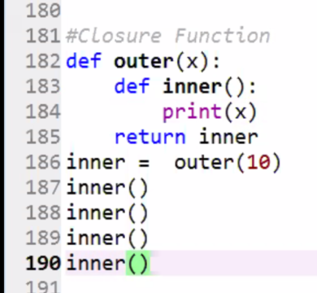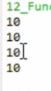

**03/07/1015**

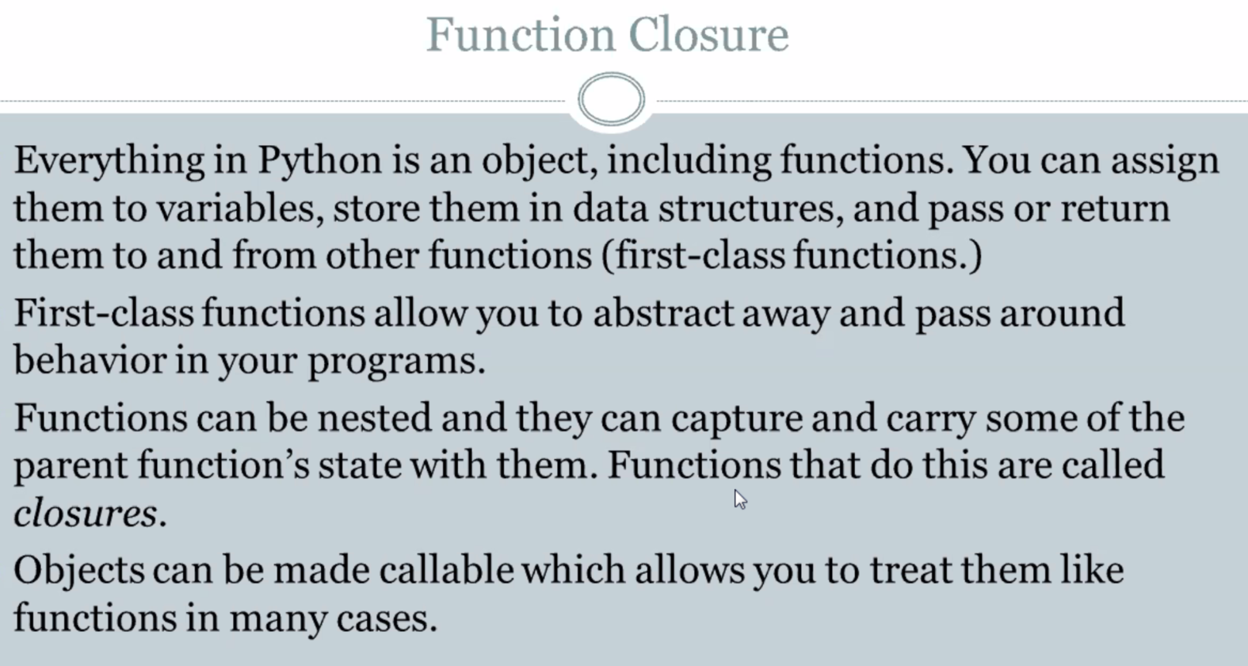

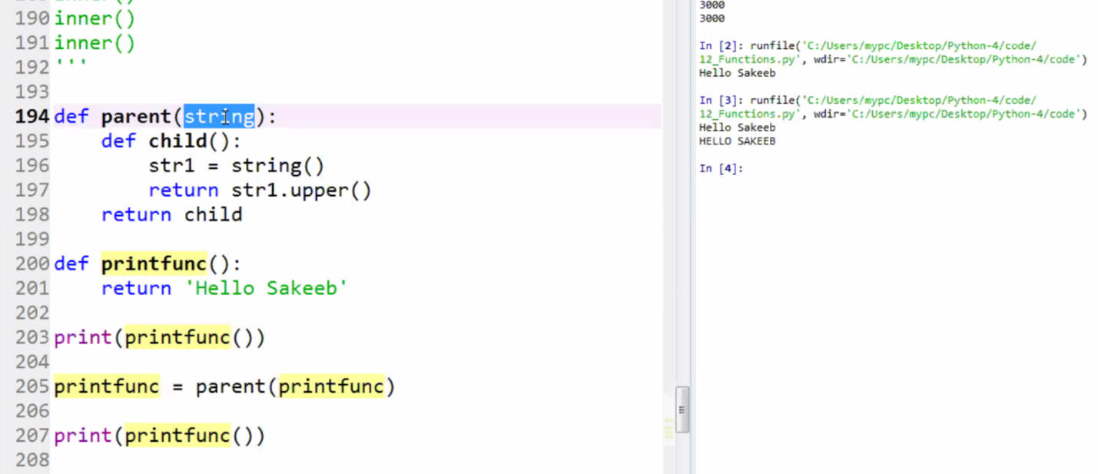

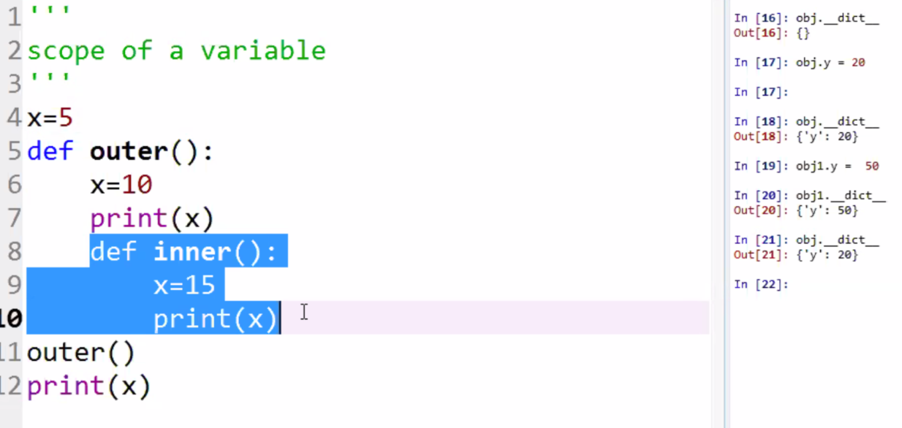

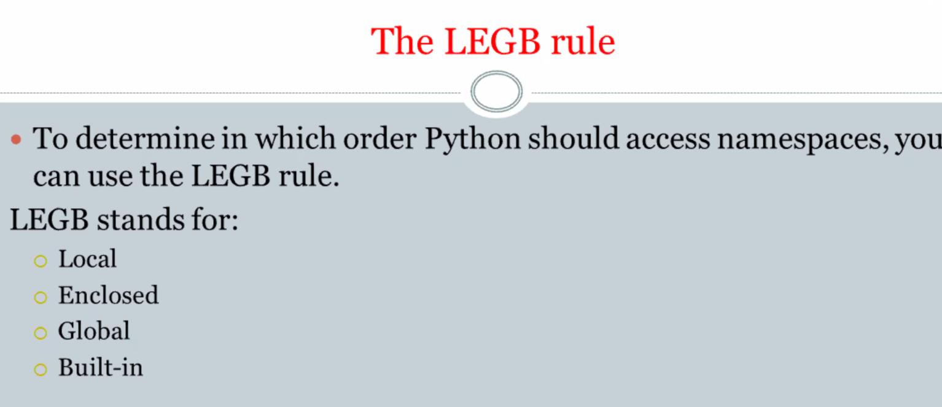

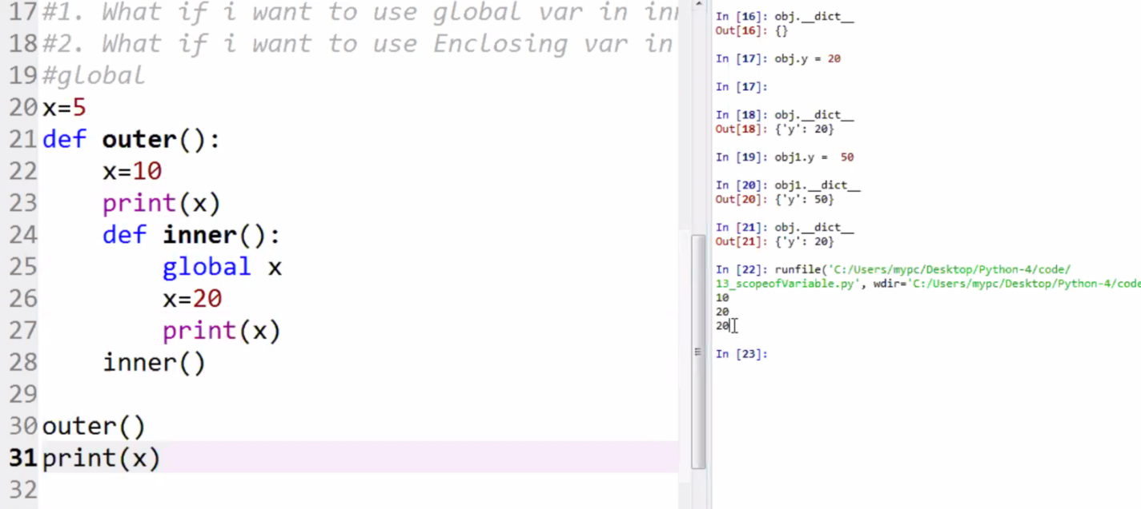

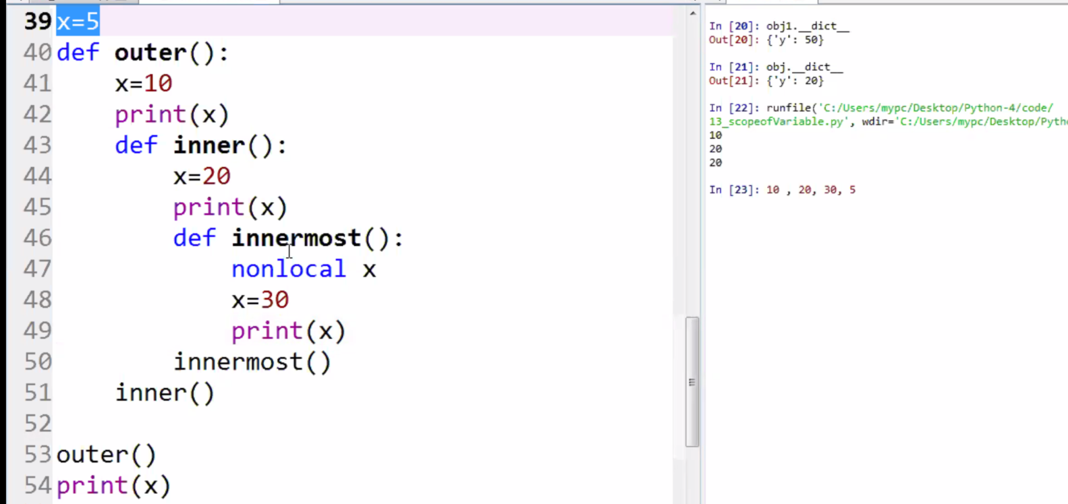

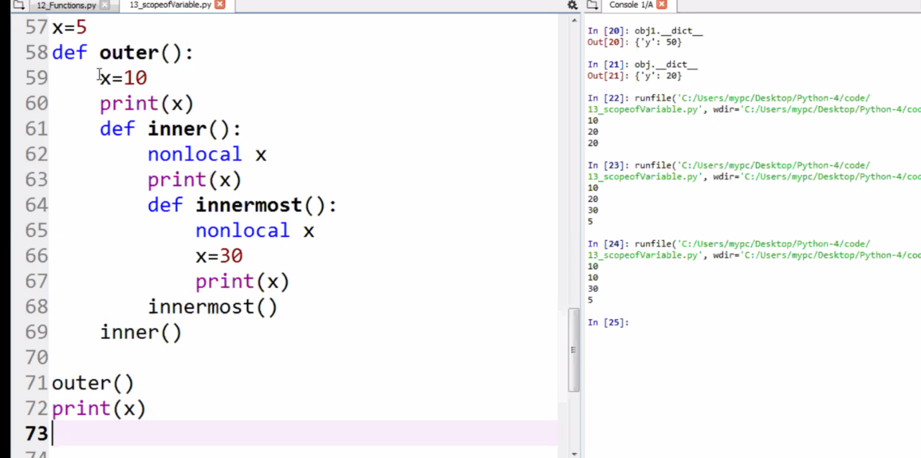

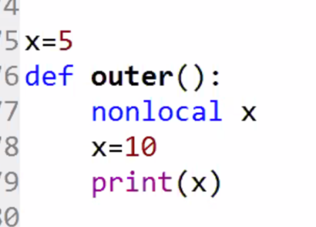

**Revisions**

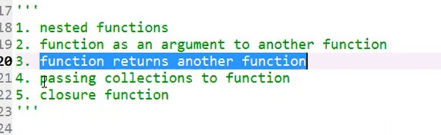

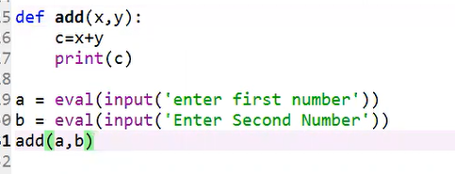

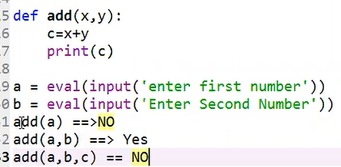

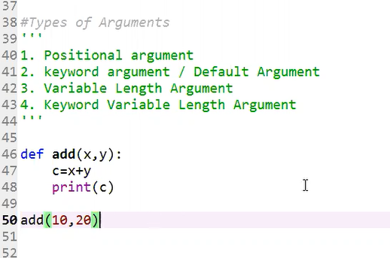

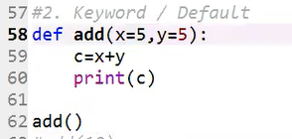**output🡪**

**Next:**

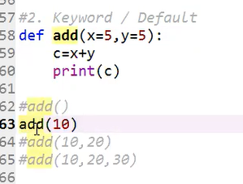**You get 15**

**Add(10) is passed positional so the value of x = 10 + value of you = 15**

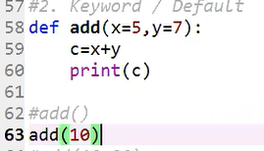 **output🡪**

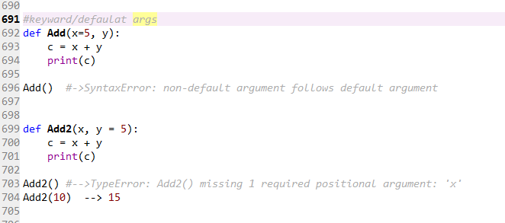

**None of the following will be executed: because you cannot follow a positional argument to a keyword argument**

**See the error message**

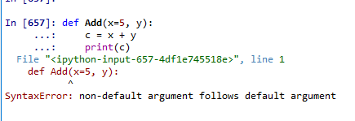

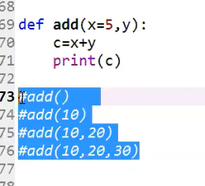

**Next**

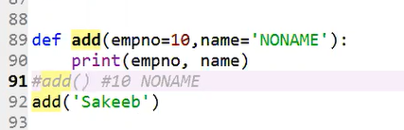

**out🡪 remember empno is overridden by “Sakeeb”**

**To fix the issue pass by** Keyword :

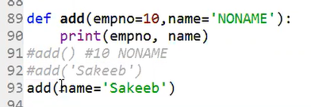

output:



Packing t:

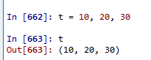

Unpacking t:

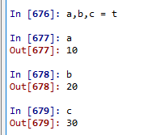

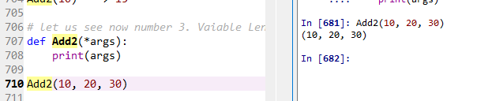

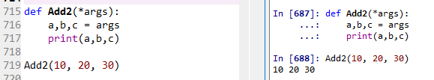

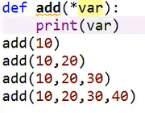output: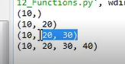

Find the sum of all:

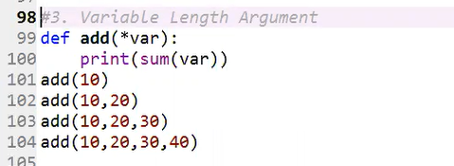 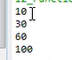

Output:

Observe these:

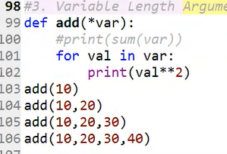output: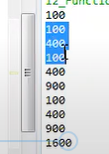

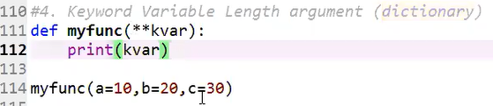

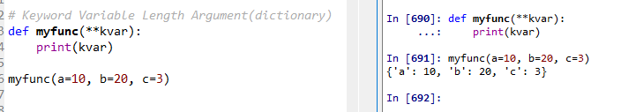

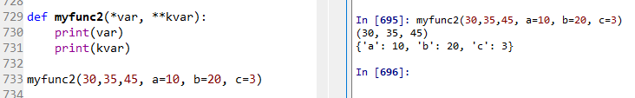

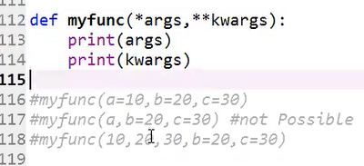

Now, let us do the functions:

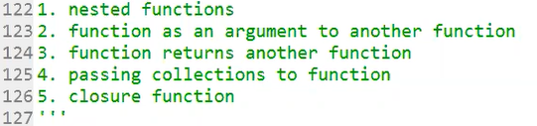

Passing functions as an arument

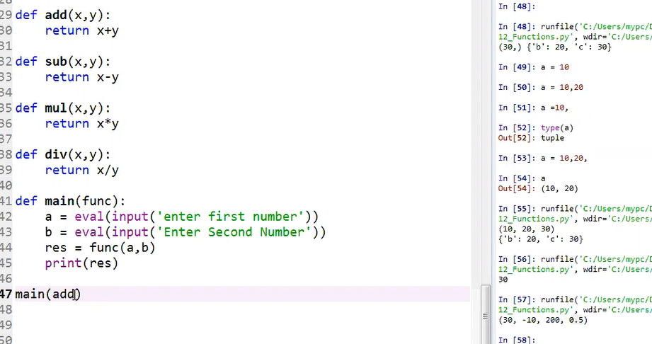

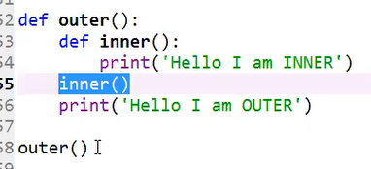output: 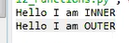

Let us see nested function:

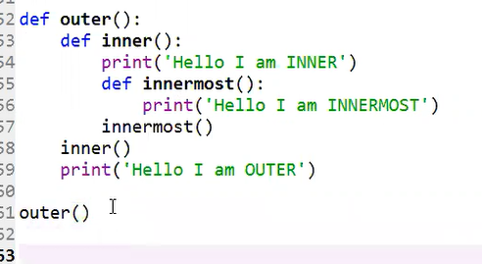 output: 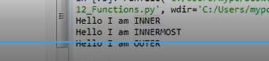

How can I call inner function without the concern of the outer function?

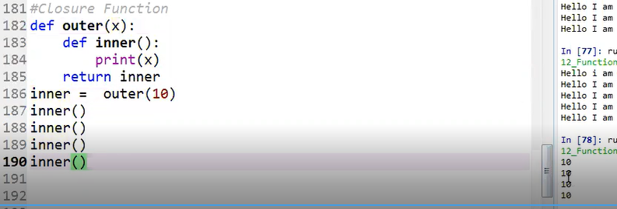

03/07/2019 lecture

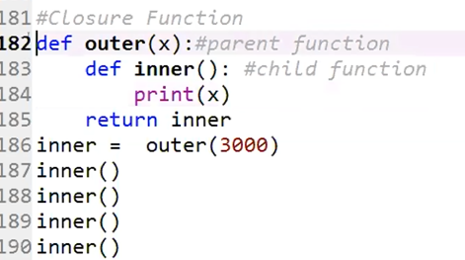

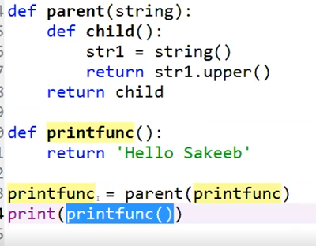

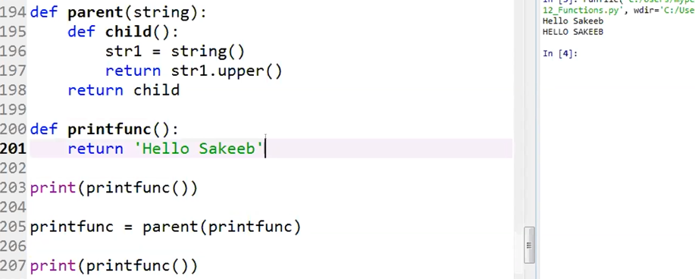

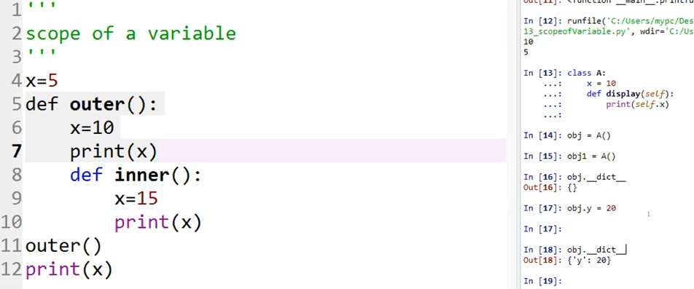

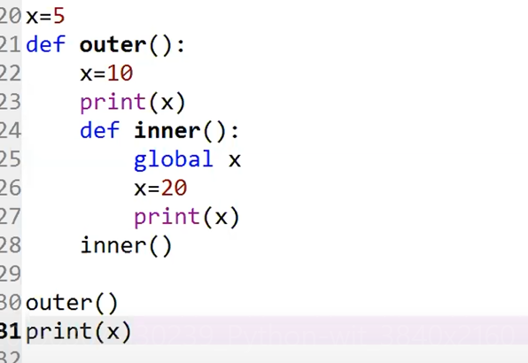output:

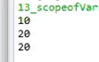

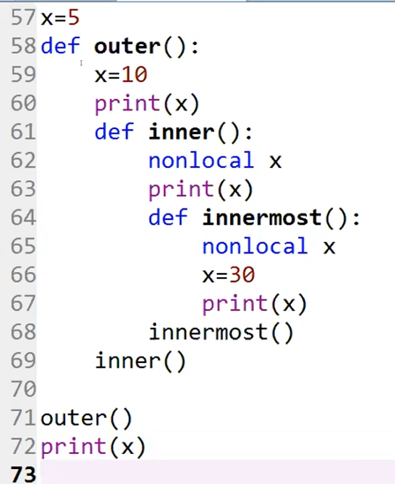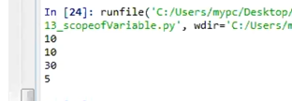

**You cannot reference a global variable by using a nonlocal variable.**

**Take the following example:**

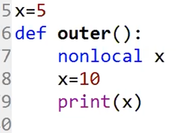

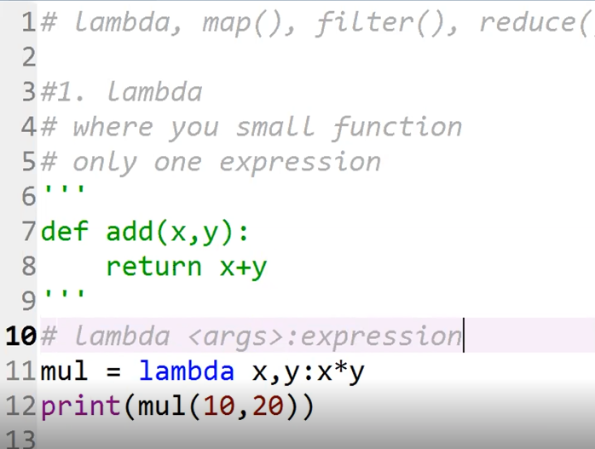

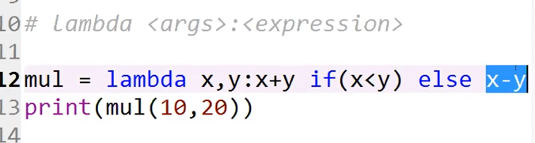

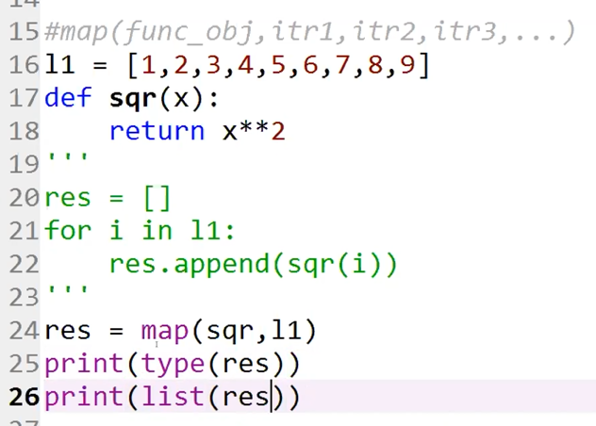

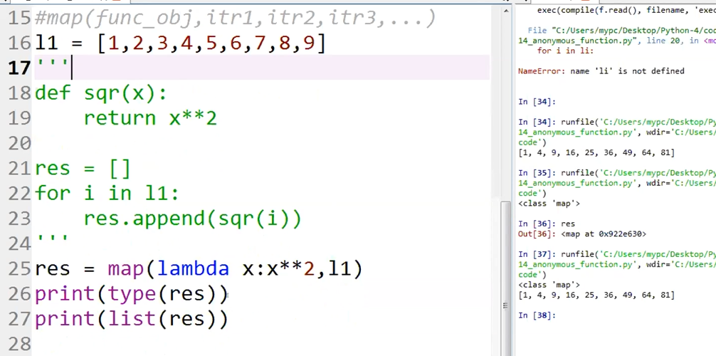

3/11/2019

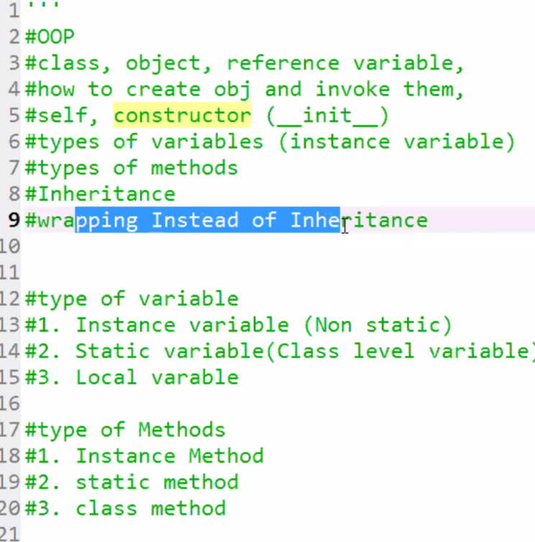

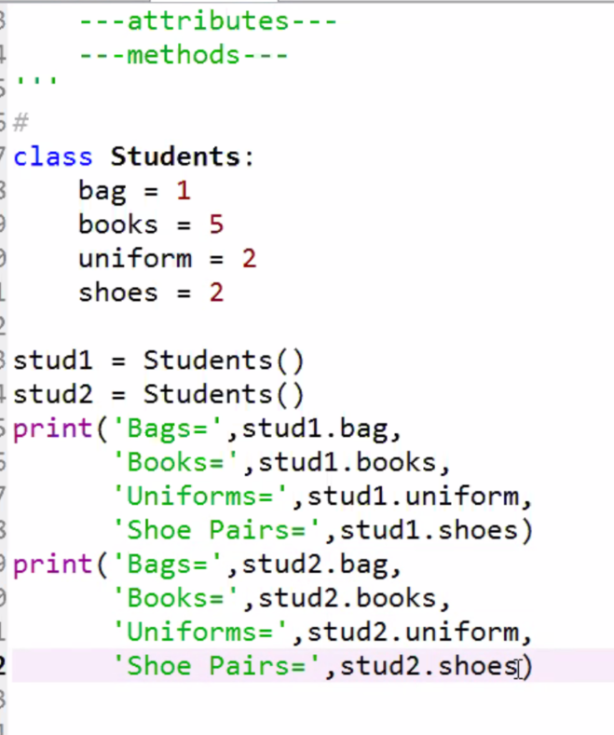 Students.__dict__

Students.__dict__

Out[179]:

mappingproxy({'__module__': '__main__',

'bag': 1,

'books': 5,

'uniform': 2,

'shoes': 2,

'__dict__': <attribute '__dict__' of 'Students' objects>,

'__weakref__': <attribute '__weakref__' of 'Students' objects>,

'__doc__': None}

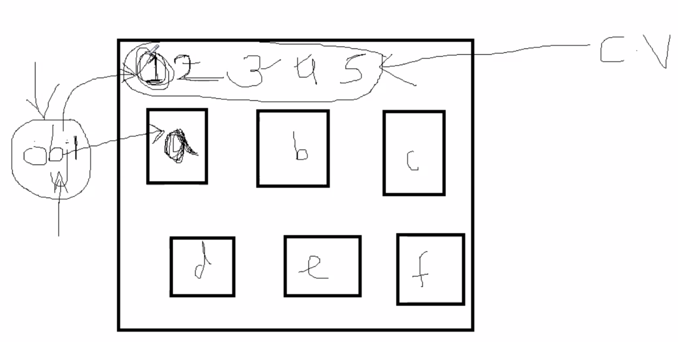

stud1.__dict__

Out[183]: {'pen': 3}

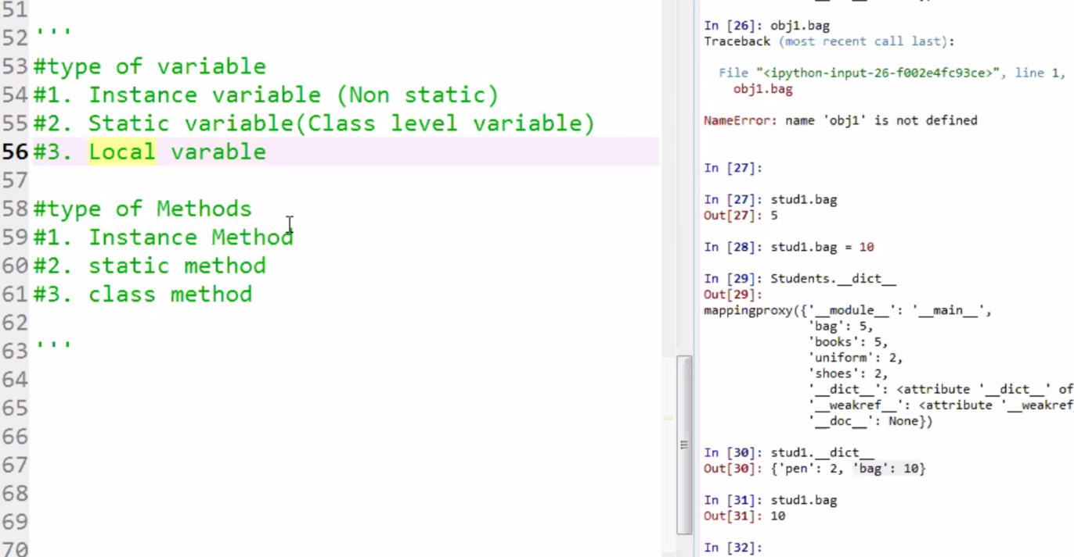

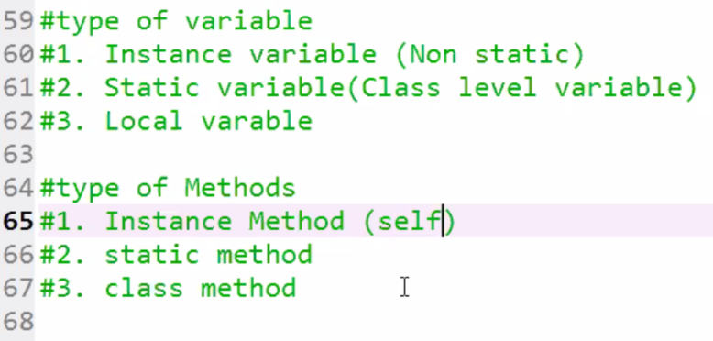

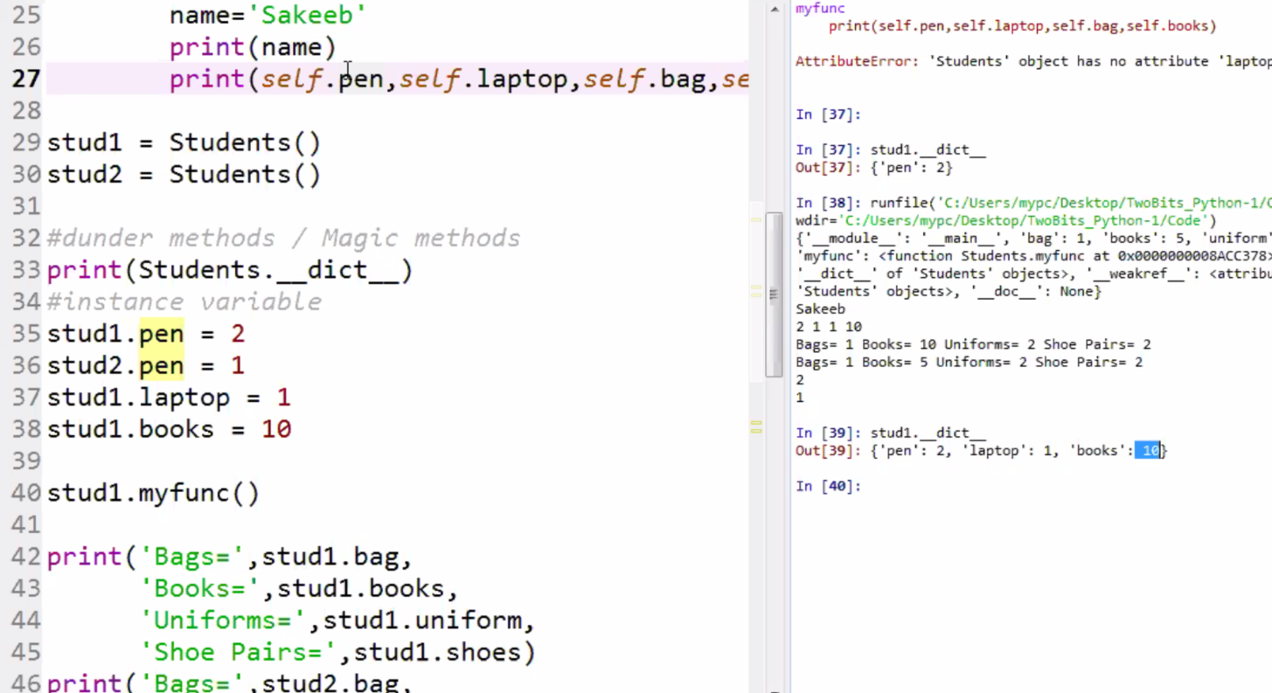

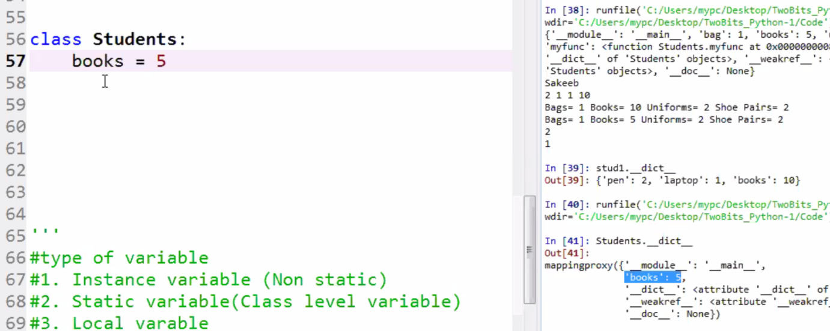

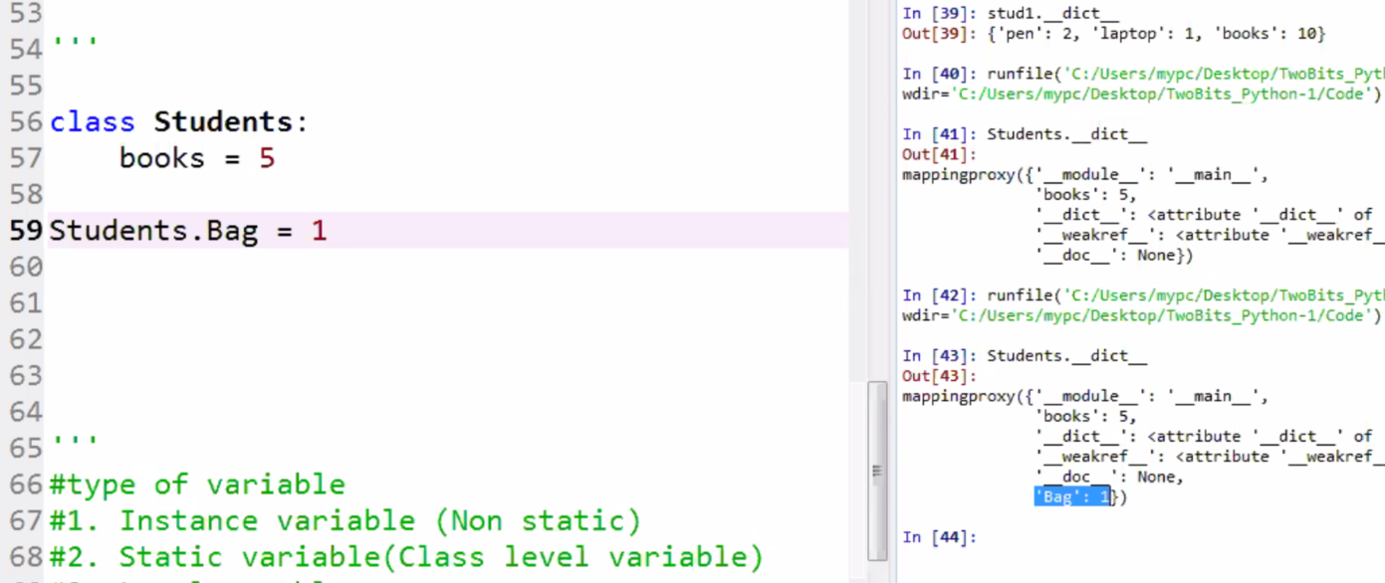

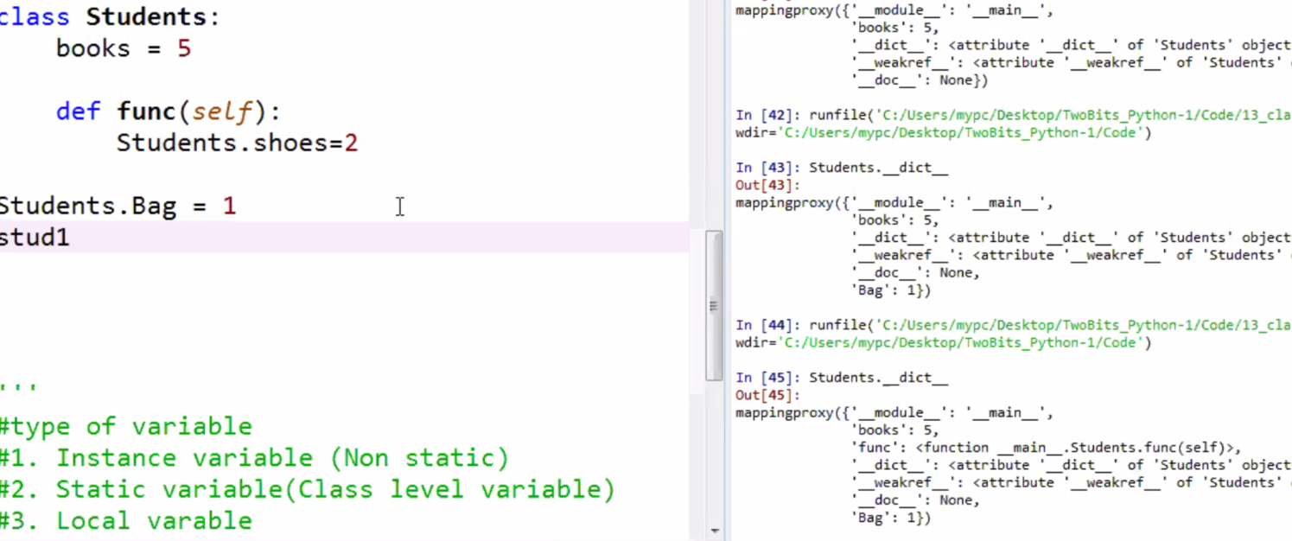

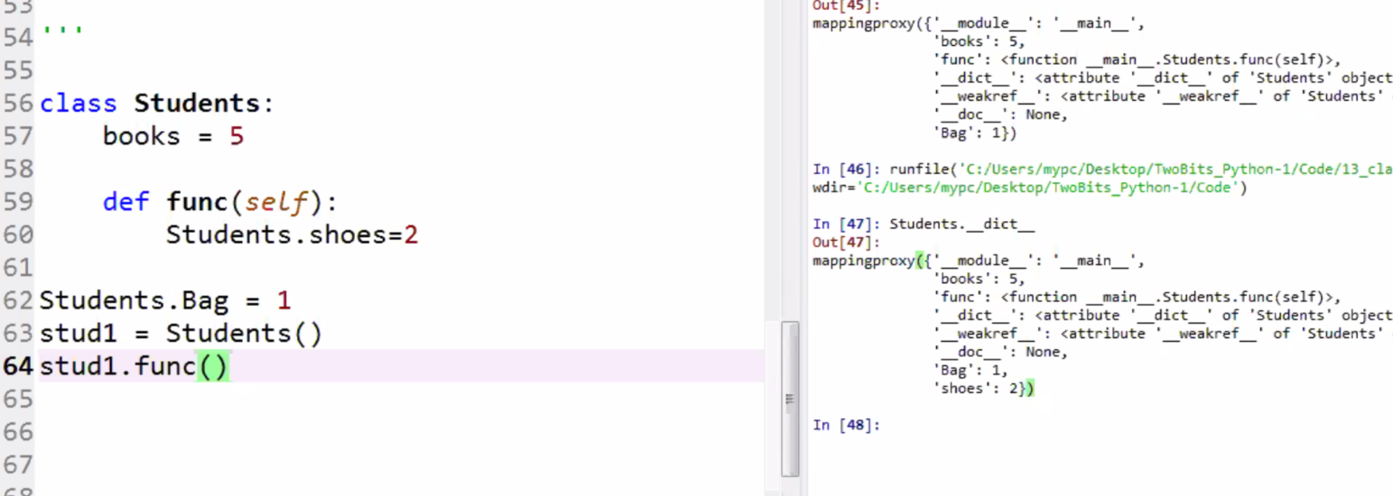

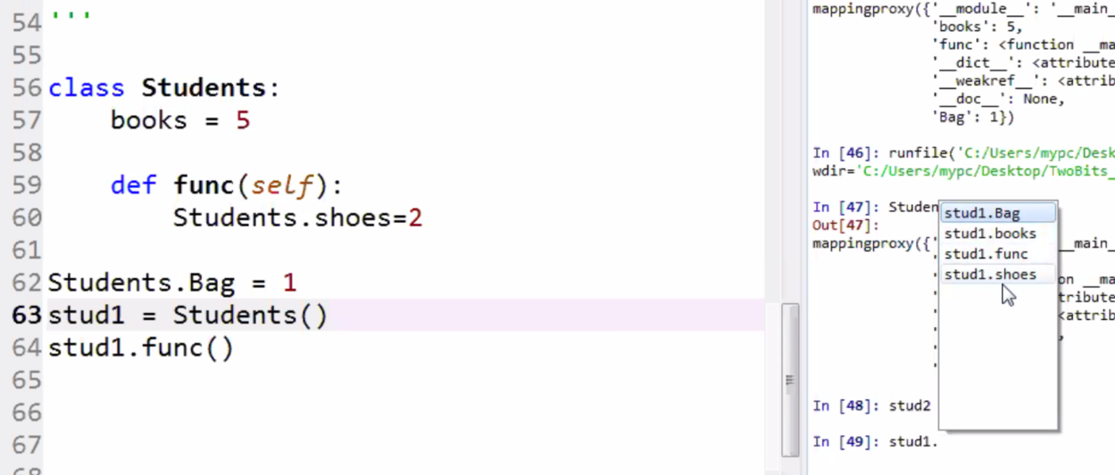

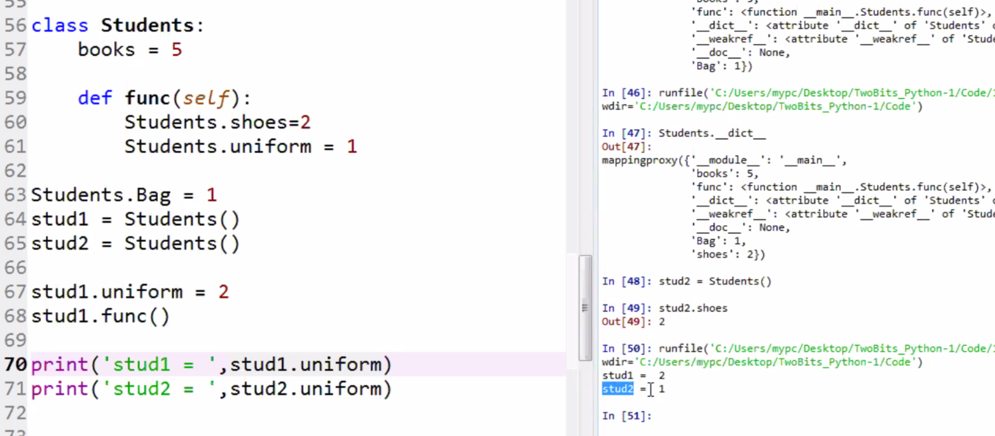

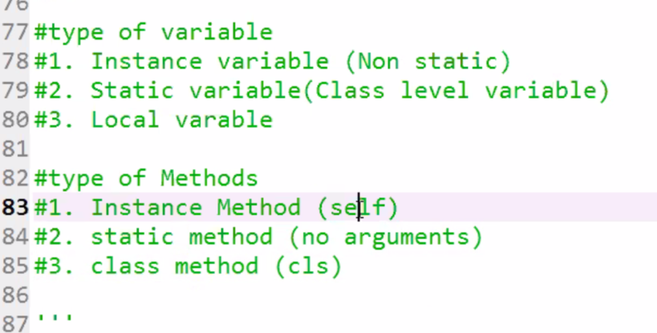

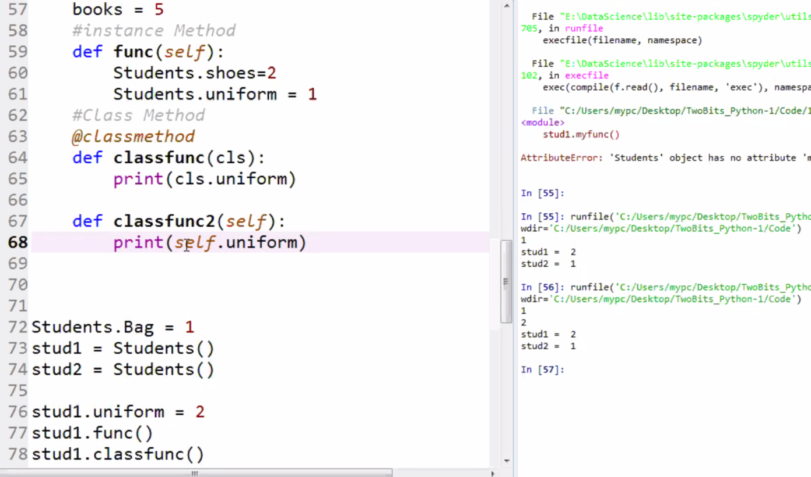

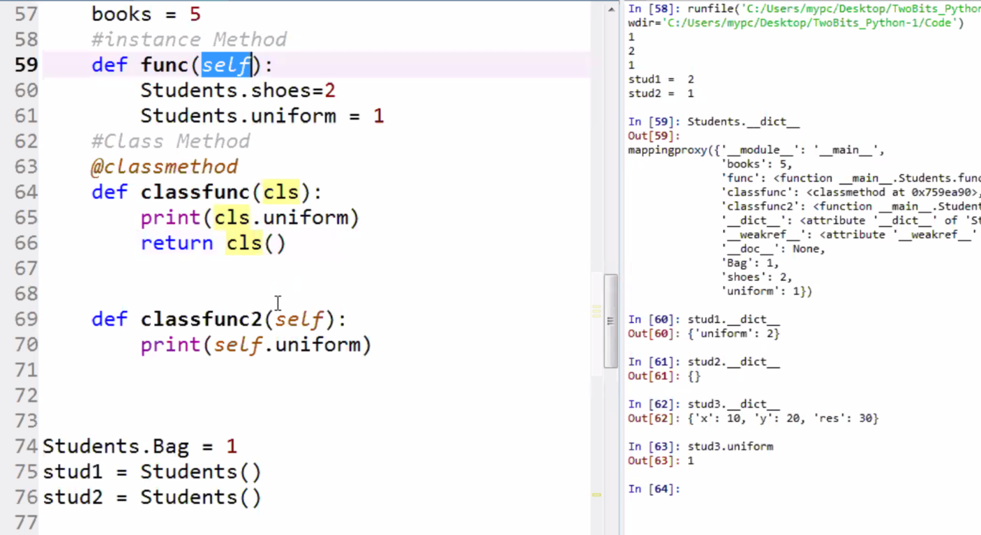

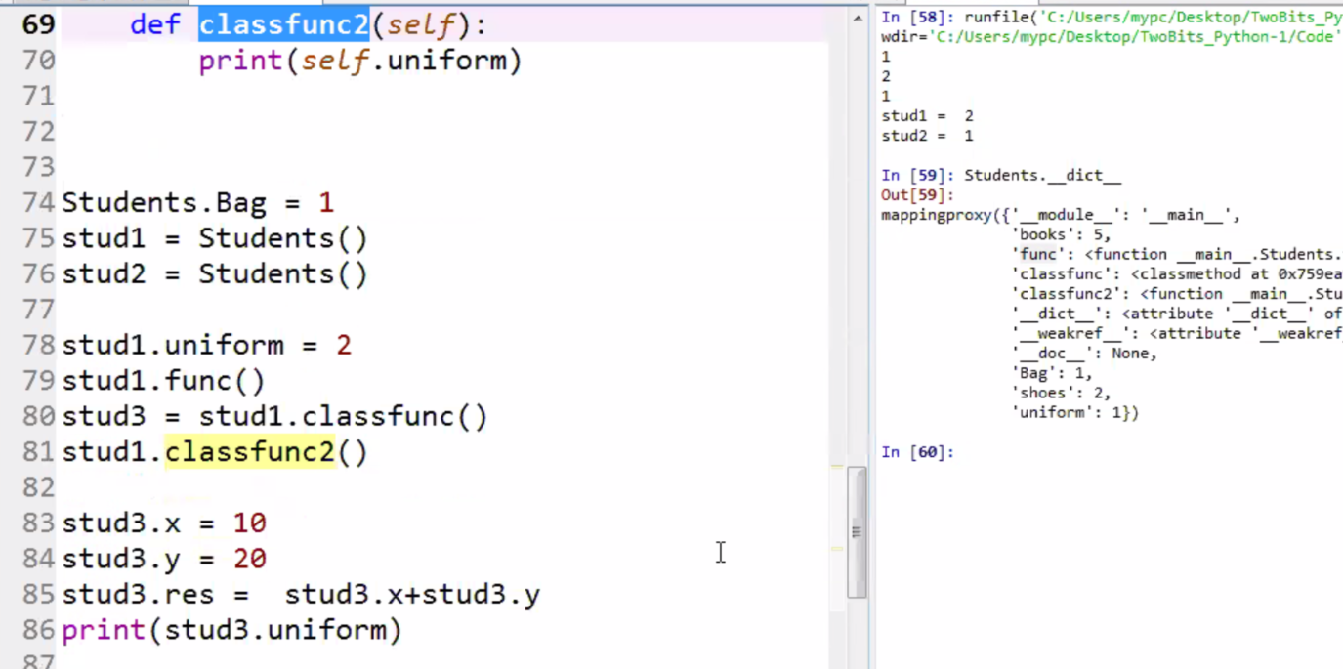

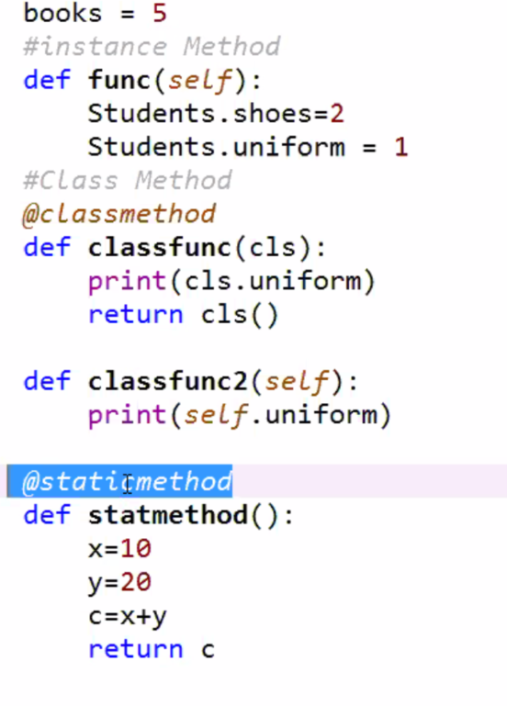

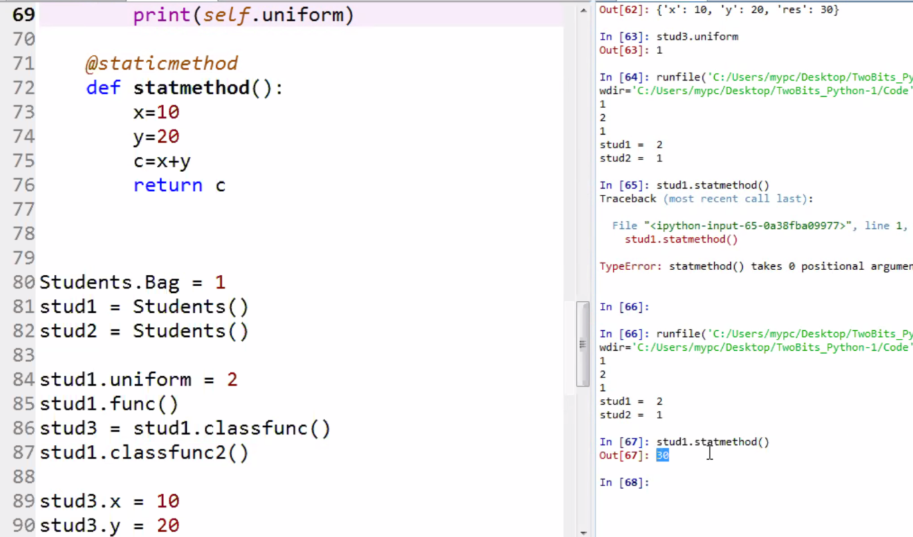

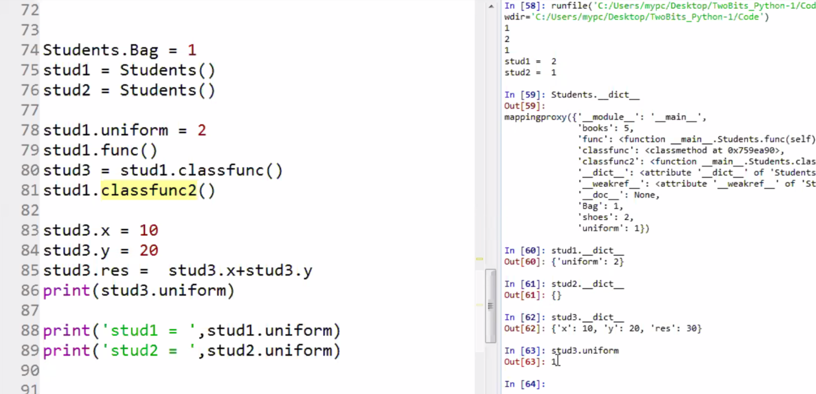

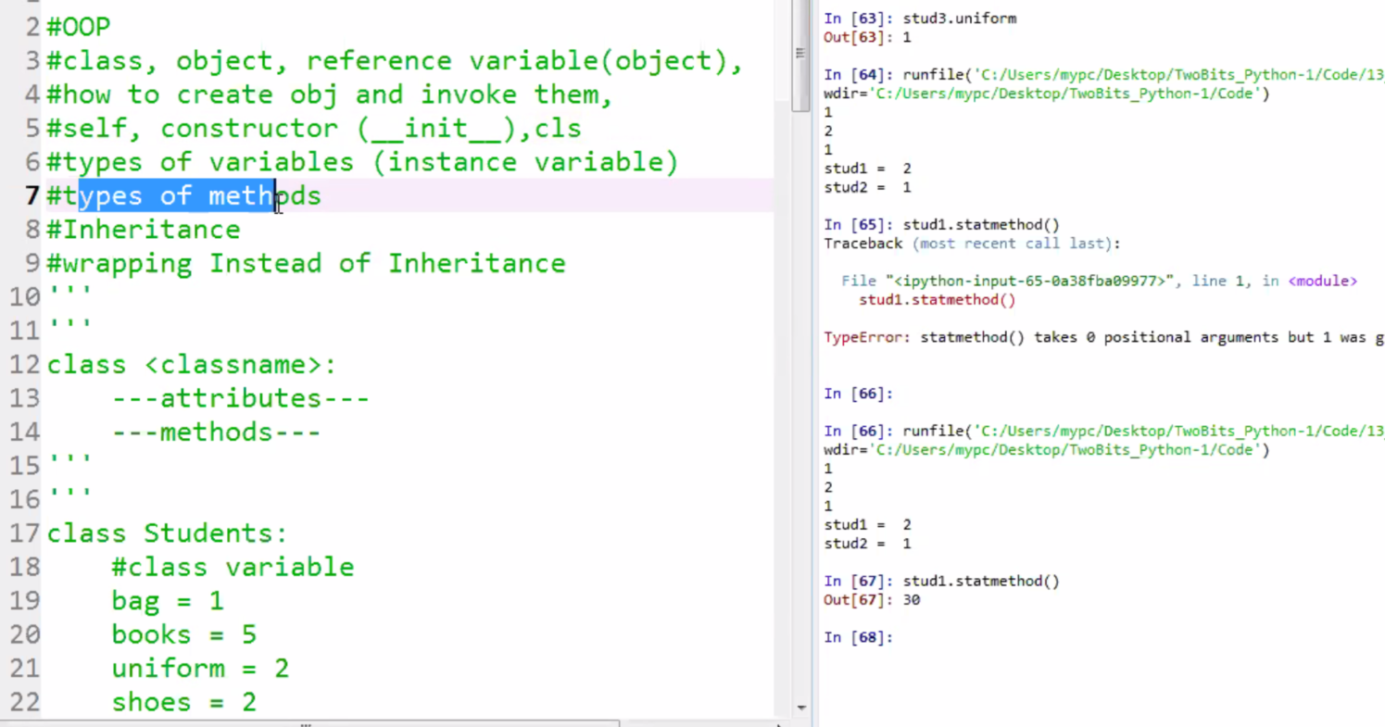

3/12/2019

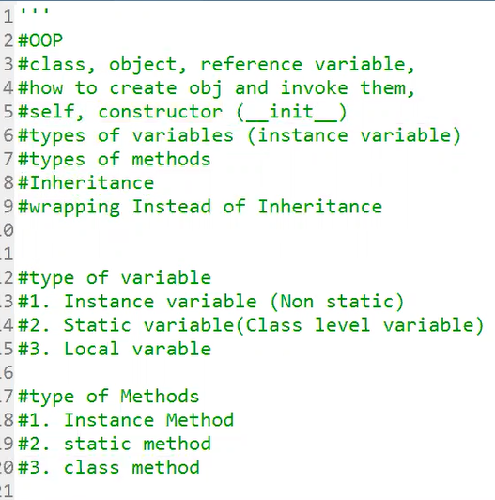

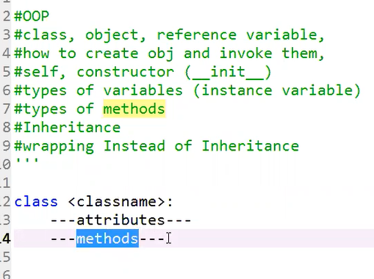

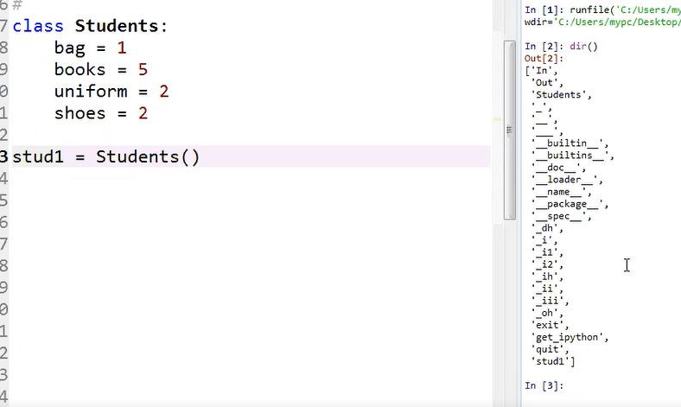

Observation:

As you can see the Class Students and the instance stud1 are created.

Amazingly, the indicated local variables are assigned when class Students

Is run. Also the instance stud1 has the 4 attributes(bag, books, uniform, and shoes)

Please note there is no method with the arugment(slef) yet. That means the attributes

are created when the class Student is loaded/run.

That means without any operations the stud1 = Students() has all 4 attributes from the class.

Then

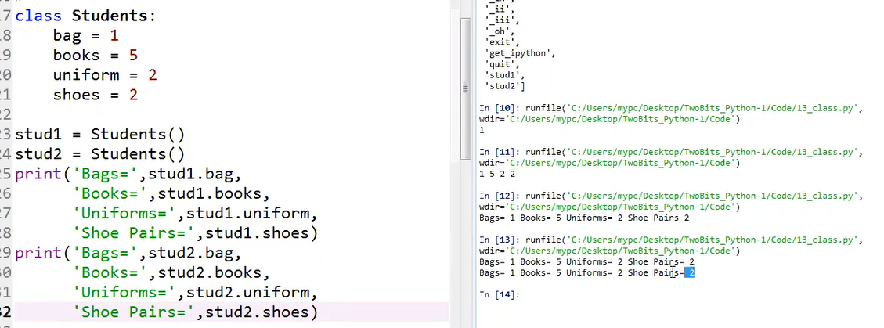

As you can see both stud1 and stud2 have the same attributes and attributes values from the class

Now let add a new attribute(pen1) to stud1 and give the value 3

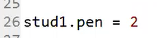

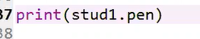

output: 

now look at the stud2 below. Please note stud2 is not assign a pen yet:

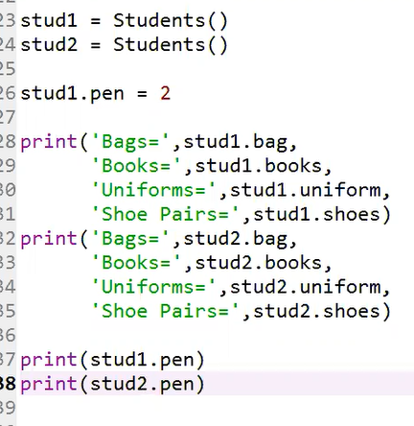

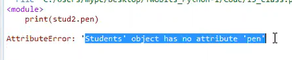

That means we can have attributes specific to a particular object if the new attribute that you assigned is not in the class Student.

Then if you add a new attribute(pen) to stud1 as shown below:

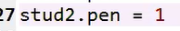

When you print it you get: 

Please study the variable types as shown below:

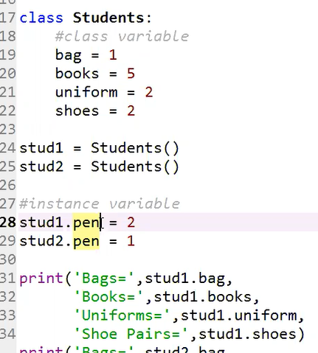

Stud1.pen – here sud1 is a reference variable.

So, the object that was created by sud1 = Students is referencing the Students

Question. Where are class variable and the instance variable in scope? Where is the boundary?

Where these variables are stored?

There is a dictionary associated with each object in Python. It defines the scope of that object

You can see by typing dir(Students)

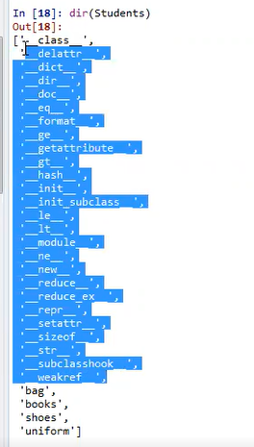

What is accessible in the dir(Students) like {bag, books, shoes, uniform) are accessible to the reference variables (stud1 and stud2. Also when you type stud1. (dot) you can see the accessible attributes

Also you can see **Students.__dict__** to see attributes and their values

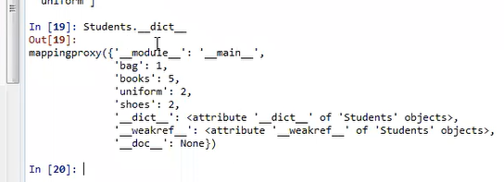

You can also access the class variables by class name (Students) 🡪 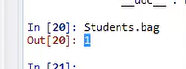

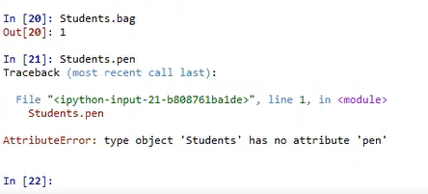

The attribute pen is not visible by the class Students because the attribute pen is object specific not a class. However if you try to see what specific attribute is associated with stud1:

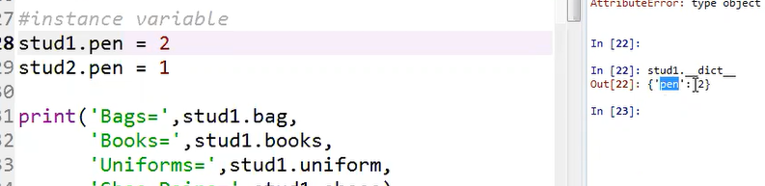

Look at the stud1.__dict__ above

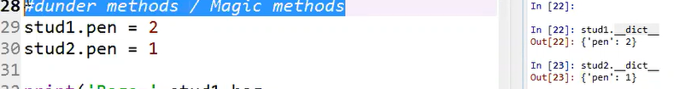

The stud1.__dict__ and stud2.__dict__ are called magic methods.

What is the rule of scope variable: LEGB –{Local, Enclosed, Global, Builtin)

Let us see big Rectangle is a class and the small rectangles are objects of the class. The numbers 1, 2, 3, 4, and 5 are attributes of the class that are seen by all objects/small rectangles. Also the specific attributes (a, b, c, d. e. f) are local attributes to the small rectangle. Now, if obj is pointing to rectangle small a (obj🡪a) is it possible obj could also see the number attributes? Yes, by the “Enclosed” rule

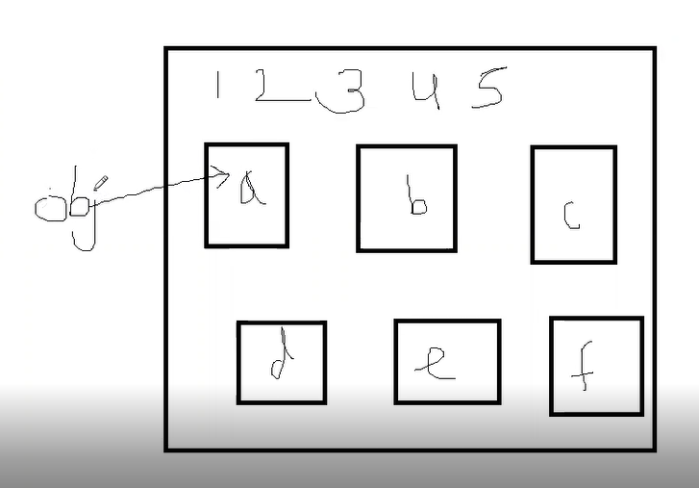

Yes, by the “Enclosed” rule

Look the following. obj1 is accessing 1 which is the Enclosed variable, and also obj1 is accessing the local variable.

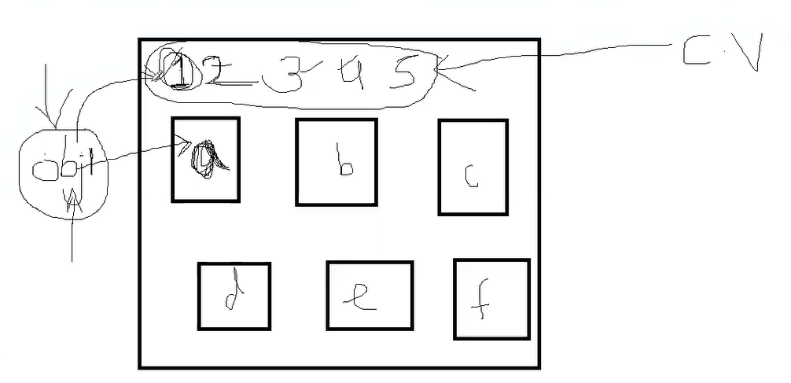

To confirm this look: 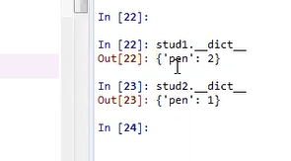

Again observe the following.

First see the following:

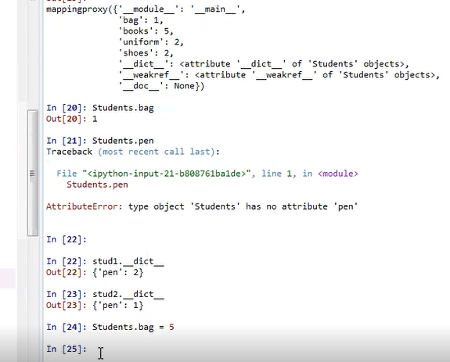

Students.bag = 1 is modified to Students.bag = 5. Now, if you type Students.__dirct__

You can see the changes:

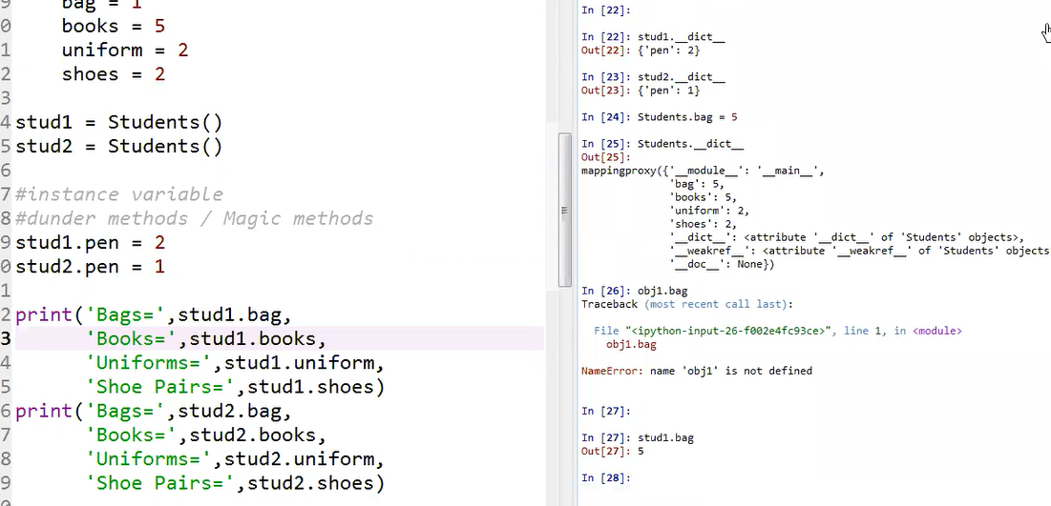

As you can see Students.__dict__ is changed to 5, and also stud1.bag is changed to 5. That means, stud1 as also access of the to the attribute that is changed by the class.

However, changing class level property by stud1 as (stud1.bag = 10) can not change the class level attribute. Stud1.bag = 10 only changes its own local not the class level attribute

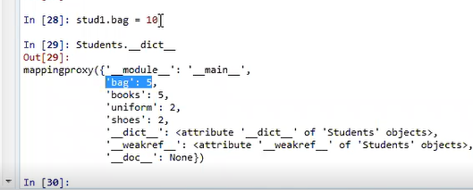

As you can see below:

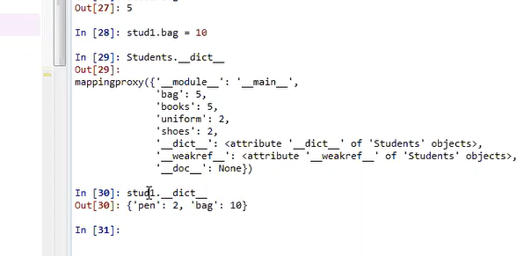

Stud1.__dict__ is changed to 10, but students.__dict__ remains as its original value (5)

So stud1.bag is now changed to 10, which local

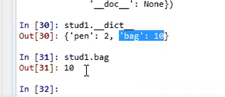

So, stud1.bag, looks for the value in its local if it is not there, then it search it in the class lever.

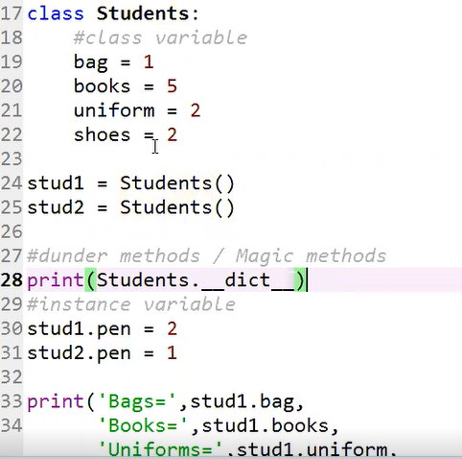

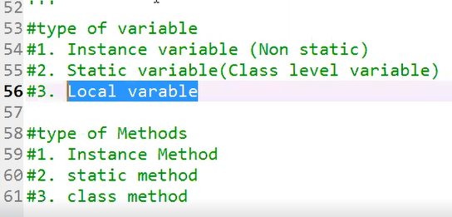

Please note the local variable (name = ‘Sakeeb’) inside the myfunc() is only accessible only the function (myfunc(). The local variable name is not accessible at class label and also by instance variables like stud1

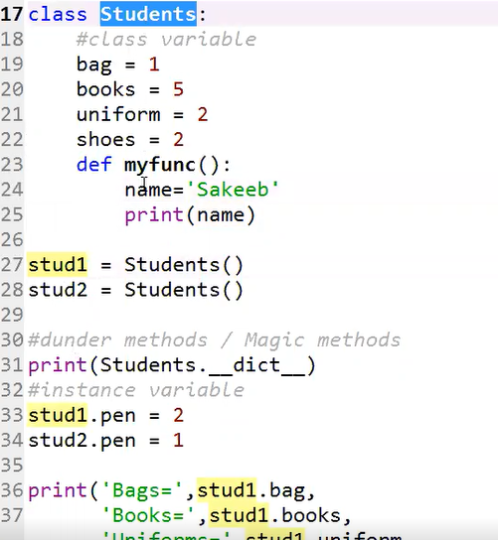

Please note that myfunc() should have an a parameter argument like myfunc(self)

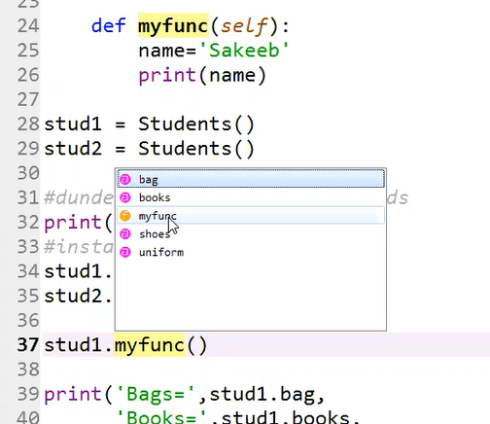

As you can see, stud1.myfunc() has access to myfunc(). Here, you do not need to pass an argument. The self is understood by default

Here is what is going on behind the seen:

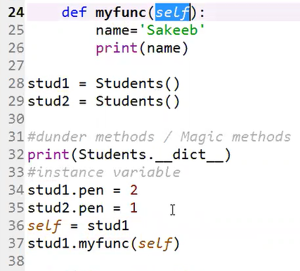

But remember, self is a default to the myfunc(self), so you can omit passing the default(self) when you call the myfunc() method. Just call myfunc() . In doing that you can access default value

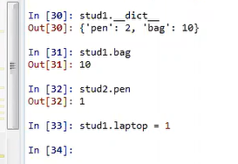

Observe new attributes added to sud1 as indicated above. Let us try to print stud1 by calling 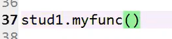

Rember, when you are calling sud1.myfunc(), you are passing an stud1 reference to the default self.

So modify myfunc() to print all attributes of the stud1

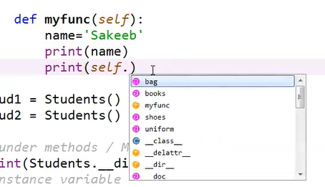

As you can see laptop attribute which was added stud1.laptob = 1 is not displayed on displayed screenshot above.

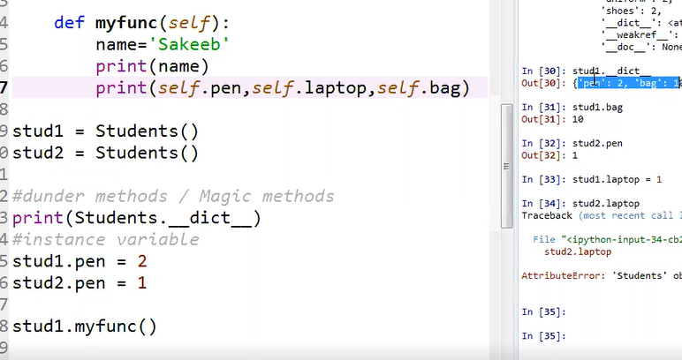

Look at the stud1__dict__

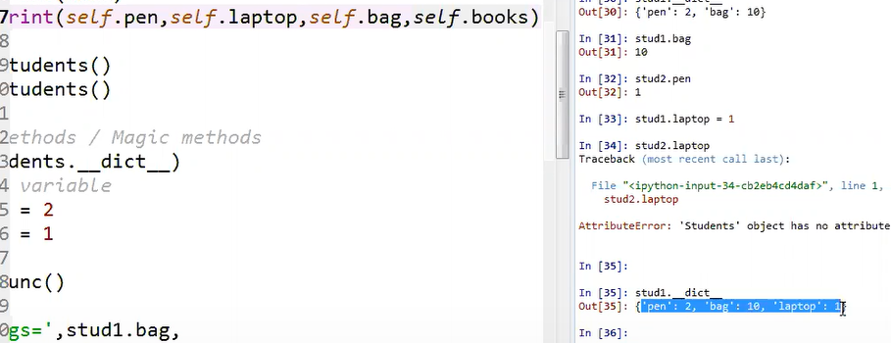

Now you call stud1.myfunc(), can you access those new attributes of stud1 and the class attributes as well? Again. Note, when you call, stud1.myfunc(), you are passing the stud1 to the def myfunc(self) as shown below

But let add/change stud1 attributes programmatically:

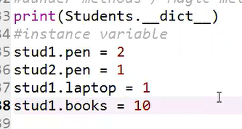

Then when you call stud1.myfunc(), you are passing stud1 to self in myfunc(self)

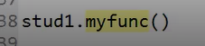

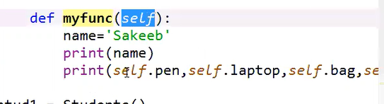

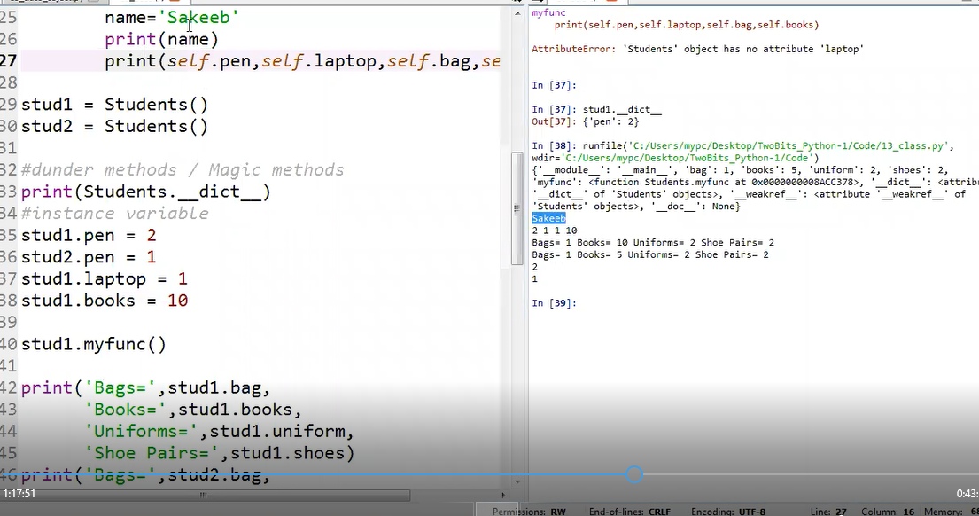

Note that self.laptob = 1 is executed, and also self.book is also executed based on the changes stud1.laptob = 10

